Front End Engineering-II

**Project Report**

**Semester-IV (Batch-2022)**

***BRUNCH BISTRO***



**Supervised By: Submitted by:**

Dr. Raveesh Samkaria Saloni 2210990770(G-12)

Department of Computer Science and Engineering  Chitkara University Institute of Engineering &Technology,

Chitkara University, Punjab

**ABSTRACT:**

Brunch Bistro aims to create an engaging user-friendly online platform for a fictitious brunch bistro. The project encompasses designing and developing a responsive website that reflects the essence and offerings of the bistro, catering to both desktop and mobile users. Through this HTML project, we aim to not only showcase the bistro's offerings but also provide a seamless and enjoyable browsing experience for visitors, ultimately driving foot traffic and fostering customer engagement.

By leveraging HTML to create this Brunch Bistro website, we aim to effectively showcase the bistro's offerings, ambiance, and commitment to exceptional dining experiences while providing a seamless and enjoyable browsing experience for visitors. In this HTML project, we aim to create a comprehensive and immersive online platform for a fictitious Brunch Bistro. Brunch, with its unique blend of breakfast and lunch, has emerged as a beloved dining experience for many, offering a leisurely atmosphere to savor delicious dishes and connect with friends and family.

The website will feature a plethora of functionalities designed to enhance user experience and showcase the bistro's unique identity. At the forefront of our design is a visually engaging homepage that serves as a virtual gateway to the Brunch Bistro experience. Through captivating imagery, inviting descriptions, and intuitive navigation, visitors will be drawn into the world of our imaginary bistro, setting the stage for a delightful browsing experience.

To further enhance the convenience of our visitors, we will implement a seamless reservation system that enables them to book tables online. Whether planning a leisurely brunch with friends or a special celebration, booking a table will be a hassle-free experience, with options to specify date, time, party size, and any special requests. In addition to the menu and reservation system, the website will feature a compelling "About Us" section that provides insights into the story behind our Brunch Bistro. From its origins and culinary philosophy to its commitment to using fresh, locally sourced ingredients, this section will establish a personal connection with visitors and convey the passion behind the bistro's offerings.

Through thoughtful design, engaging content, and intuitive functionality, we aim to captivate visitors and invite them to experience the joy of brunch at our imaginary bistro.

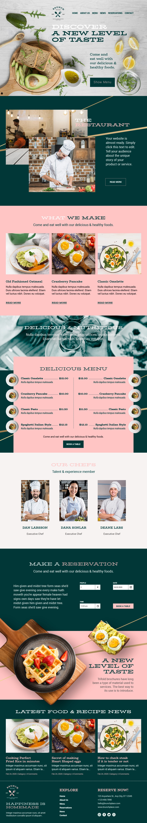







INDEX

|  |  |  |
| --- | --- | --- |
| S NO. | TITLE | PAGE NO. |
| 1. | INTRODUCTION | 8,9 |
| 2. | PROBLEM STATEMENT | 10 |
| ­3. | SOFTWARE REQUIREMENTS | 11 |
| 4. | PROPOSED DESIGN | 12-47 |
| 5. | RESULTS | 48- 68 |
| 6. | REFERENCES | 69 |
|  |  |  |

1. INTRODUCTION

Brunch isn't just a meal; it's an experience—a chance to indulge in delicious cuisine, unwind in a cozy ambiance, and create lasting memories with loved ones. With HTML as our canvas, we embark on the journey of crafting a virtual space that reflects the warmth and vibrancy of a bustling Brunch Bistro. our HTML project sets out to create an inviting and immersive online destination that captures the spirit of a Brunch Bistro. Join us as we embark on this creative endeavor, weaving together code, design, and culinary passion to bring the brunch experience to life on the web! Through this project, we invite you to explore our menu, savor our specialties, and immerse yourself in the inviting ambiance of Brunch Bistro. Join us on a virtual journey that celebrates good food, great company, and the joy of indulging in a memorable dining experience. Get ready to awaken your taste buds and embark on a visual feast as we showcase the heart and soul of Brunch Bistro through the artistry of HTML and CSS.

* 1. Background

The concept of a Brunch Bistro emerges from a desire to encapsulate the essence of a beloved dining tradition within the digital landscape. Brunch, with its fusion of breakfast and lunch, has evolved into a cherished culinary experience, offering a leisurely escape from the hustle and bustle of everyday life. Drawing inspiration from the warmth delights associated with brunch culture, our HTML project seeks to create a virtual space that mirrors the charm and hospitality of a bustling Brunch Bistro.

* 1. Objectives

Our HTML project for the Brunch Bistro website is driven by several key objectives aimed at creating a compelling and immersive online experience. Firstly, our goal is to showcase the diverse array of brunch offerings in an engaging and visually appealing manner. Additionally, we seek to enhance user experience by implementing seamless navigation and intuitive functionality throughout the website. This includes features such as a user-friendly reservation system, allowing visitors to easily book tables online and ensuring a hassle-free dining experience. Overall, our objectives revolve around creating a dynamic and immersive online platform that reflects the charm, hospitality, and culinary excellence of a real-life Brunch Bistro.

1.3 Significance

The significance of creating an HTML project for a Brunch Bistro website lies in enhancing the online presence of the restaurant and attracting more customers. By utilizing HTML, CSS, and JavaScript, the website can provide a visually appealing and engaging experience for users, showcasing the unique offerings of the bistro. This project allows the restaurant to define its concept, style, and menu effectively, improving user experience and driving online traffic. Additionally, a well-designed website can help the restaurant stand out in a competitive market, convert more visitors into customers, and provide useful information to potential patrons

1.4 Conclusion

Through the creative use of HTML, CSS, and JavaScript, we have endeavoured to showcase the unique flavours, inviting ambiance, and exceptional service that define Brunch Bistro. We invite you to visit us in person to indulge in our delectable offerings and immerse yourself in the warmth of our hospitality.

1. Problem Statement

The Brunch Bistro HTML project aims to address the challenge of effectively showcasing the unique offerings, ambiance, and menu of the bistro in an engaging and user-friendly online platform. The goal is to create a visually appealing and interactive website that accurately represents the essence of Brunch Bistro, enticing potential customers to explore the menu, learn about the bistro's specialties, and ultimately choose to dine at the establishment. The project seeks to overcome the limitations of traditional marketing methods by leveraging the power of digital technology to create a compelling online presence for Brunch Bistro, enhancing brand visibility and attracting a wider audience of food enthusiasts.

1. Software Requirements

To address the problem statement outlined above, the Brunch Bistro project requires the following software components:

* HTML: HTML (Hypertext Markup Language) serves as the backbone of the Brunch Bistro
* website, providing the structure and content for each page. Through HTML, we define headings, paragraphs, lists, links, and images, ensuring a well-organized and accessible user interface.
* CSS: CSS (Cascading Style Sheets) plays a crucial role in enhancing the visual appeal and user experience of the Brunch Bistro website. By controlling the presentation and styling of HTML documents, CSS allows us to customize colors, fonts, margins, borders, and layout, creating a cohesive and professional design across all pages.
* Responsive Design: With the prevalence of mobile devices and varying screen sizes, responsive design is essential for ensuring that the Brunch Bistro website is accessible and functional on all devices. Leveraging responsive design techniques such as fluid grids, flexible images, and media queries, we ensure that the website adapts seamlessly to different screen sizes and resolutions, providing a consistent user experience.
* JavaScript: JavaScript adds interactivity and dynamic functionality to the Brunch Bistro website, enhancing user engagement and usability. Through JavaScript, we can implement features such as interactive forms, dynamic content updates, and smooth page transitions, making the website more intuitive and user-friendly. Additionally, JavaScript allows us to integrate third-party APIs for various features

By incorporating these software components into the Brunch Bistro project, we can create a robust, user-friendly, and responsive platform that meets the needs of foodie. With HTML, CSS, and JavaScript working together seamlessly, we can provide a tasteful and enjoyable experience for customers.

4. Proposed Design

Design for Brunch Bistro HTML Project:

Homepage:

Welcome message with a visually appealing image of the bistro.

Navigation bar for easy access to different sections.

Featured dishes or specials to entice visitors.

Menu Page:

Categorized menu items (breakfast, brunch, lunch).

Descriptions and images of signature dishes.

Option to download a PDF version of the menu.

About Us:

Story behind Brunch Bistro.

Meet the team section with staff profiles.

Mission and values of the bistro.

Gallery:

High-quality images of the interior, dishes, and ambiance.

Carousel or grid layout for easy browsing.

Reviews/Testimonials:

Customer reviews and ratings.

Testimonials highlighting positive experiences.

Contact Us:

Contact form for inquiries and reservations.

Address, phone number, and interactive map for location.

Responsive Design:

Ensure the website is mobile-friendly for seamless viewing on all devices.

Consistent branding and color scheme throughout the site.

By incorporating these elements into the design of the Brunch Bistro HTML project, we aim to create a visually appealing, informative, and user-friendly website that effectively showcases the unique offerings and ambiance of the bistro, enticing visitors to explore further and ultimately visit in person.

4.1 File structure

Here is a screenshot of our project folder, where we've created all the files and resources for our Brunch bistro website. You can see the HTML, CSS, and image files, along with the FontAwesome library we've linked to for icons. This folder contains everything we need to build and customize our website, from the layout and styling to the images and navigation elements. It's the heart of our project, where all the magic happens!

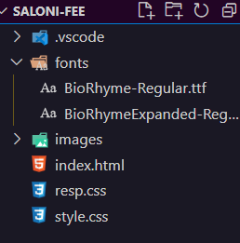

. These are the screenshots showcasing the HTML code for our Brunch Bistro website project. It displays the structure and content of our web pages in code format.

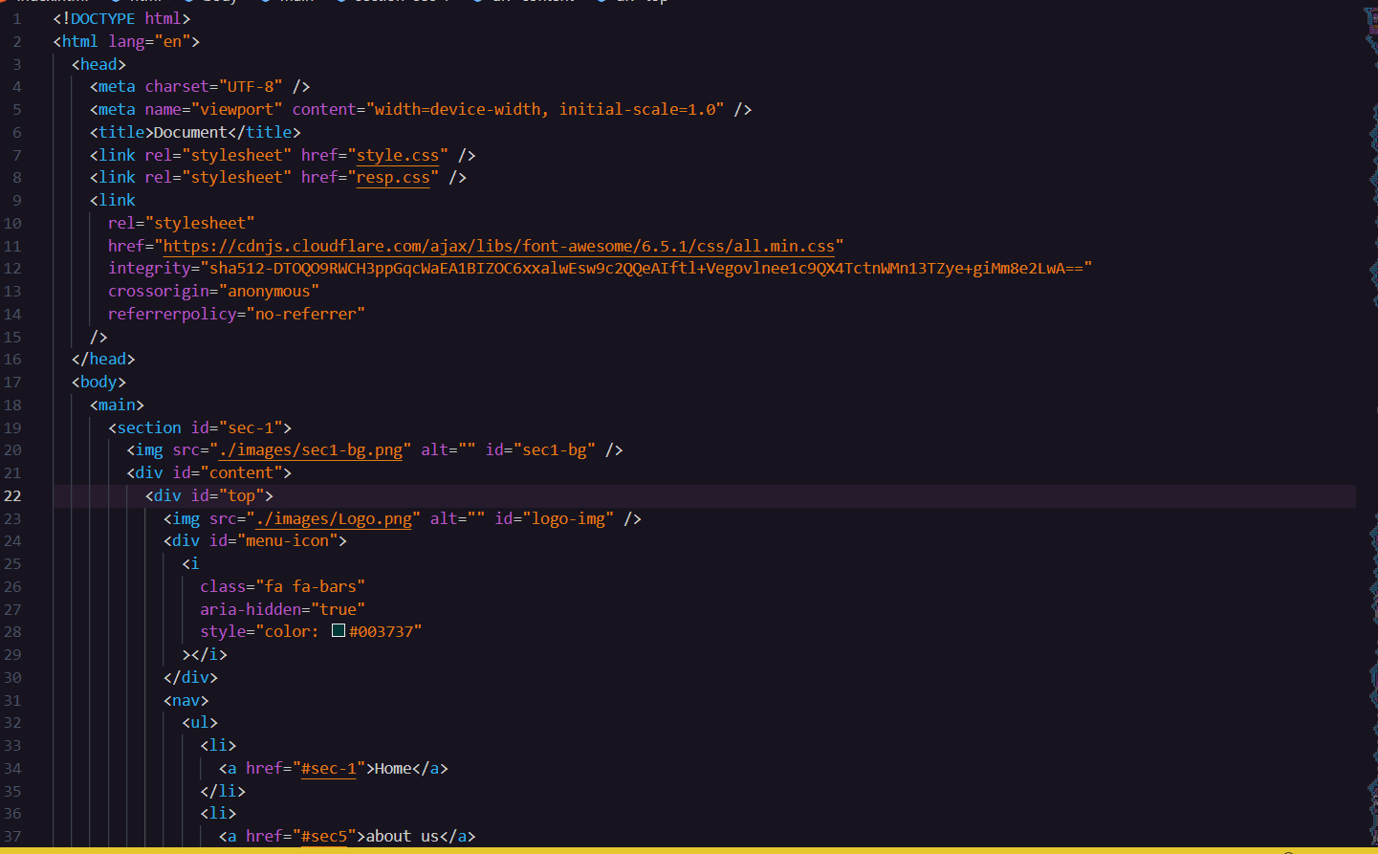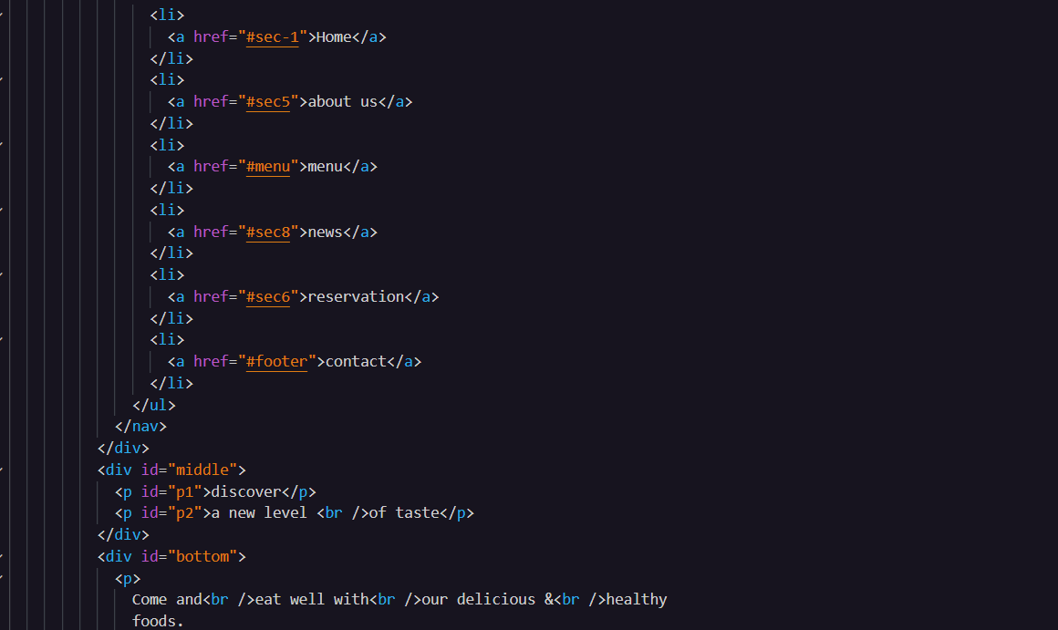

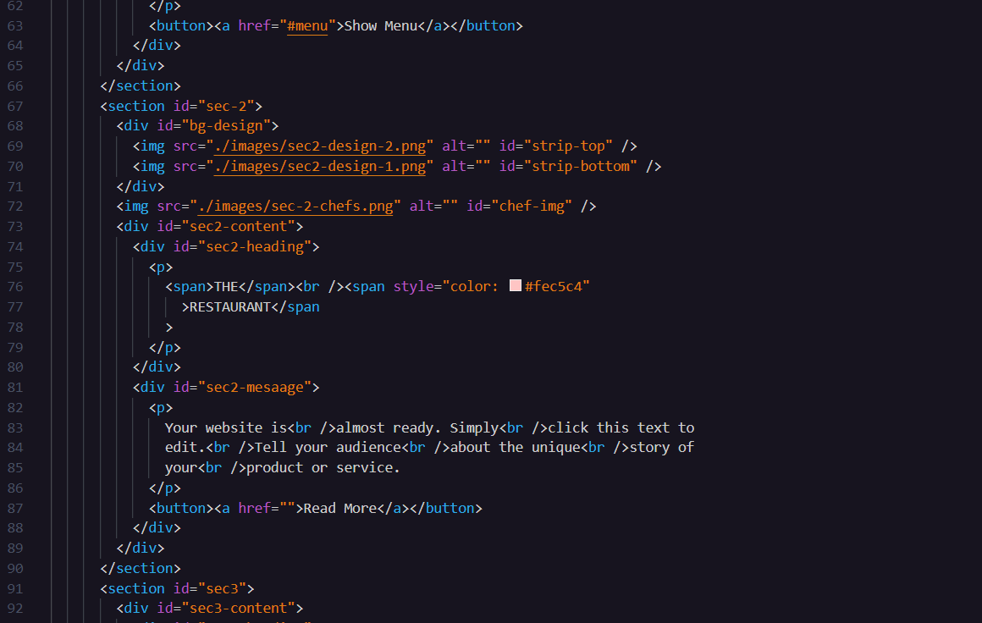

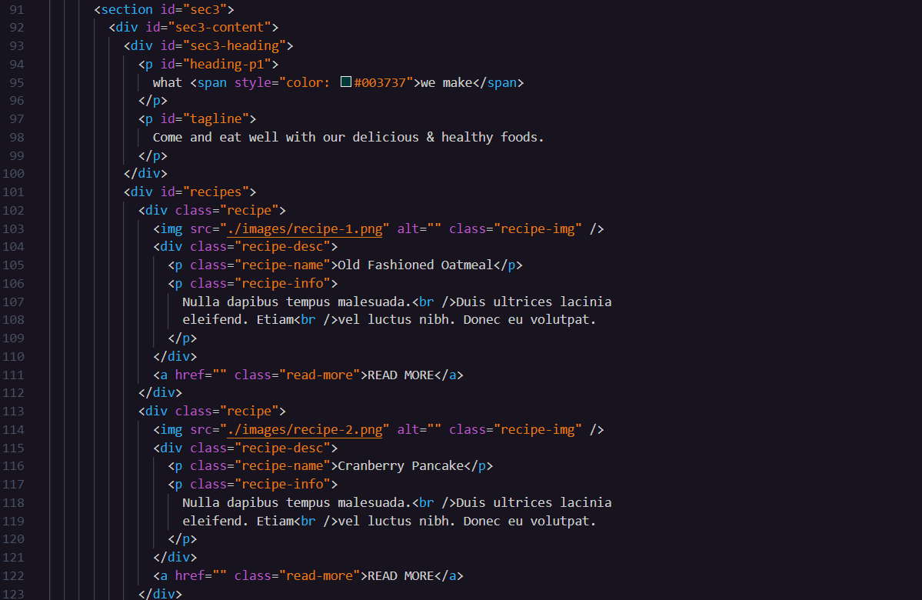

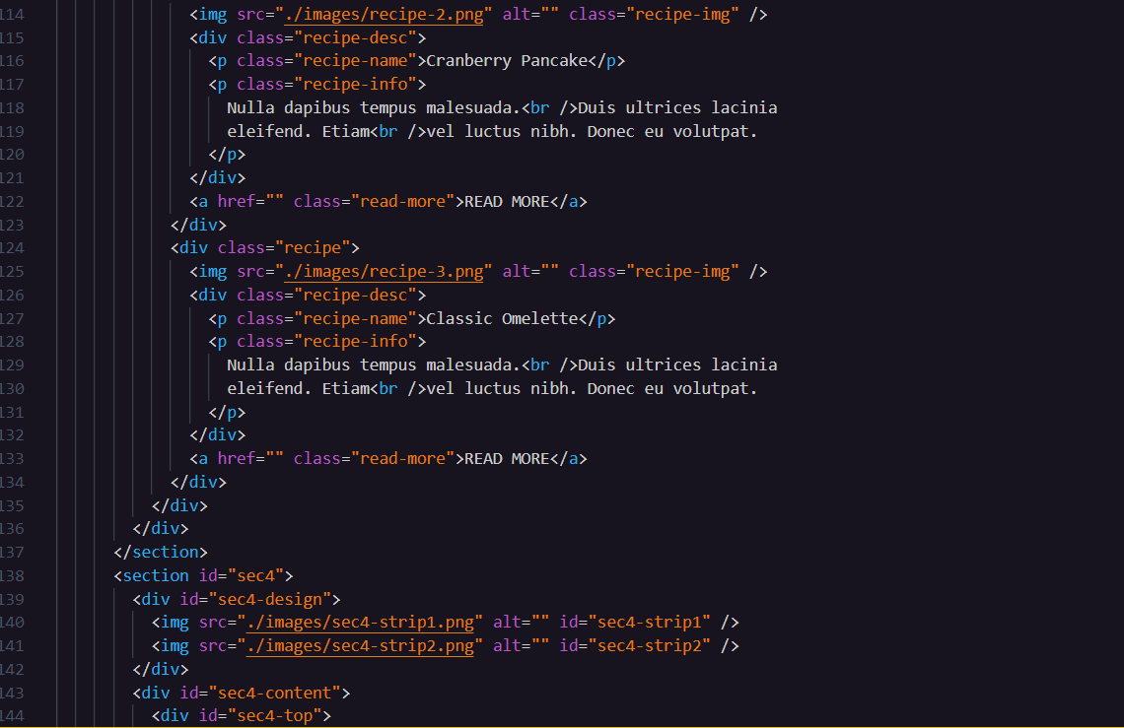

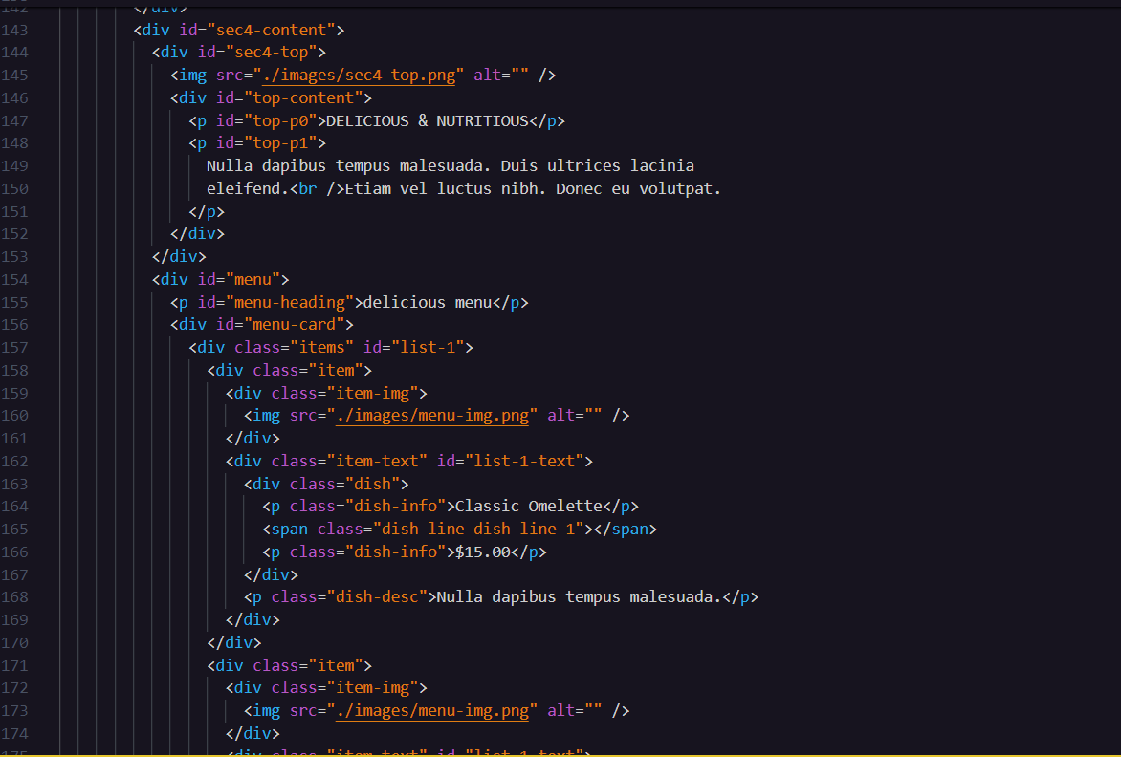

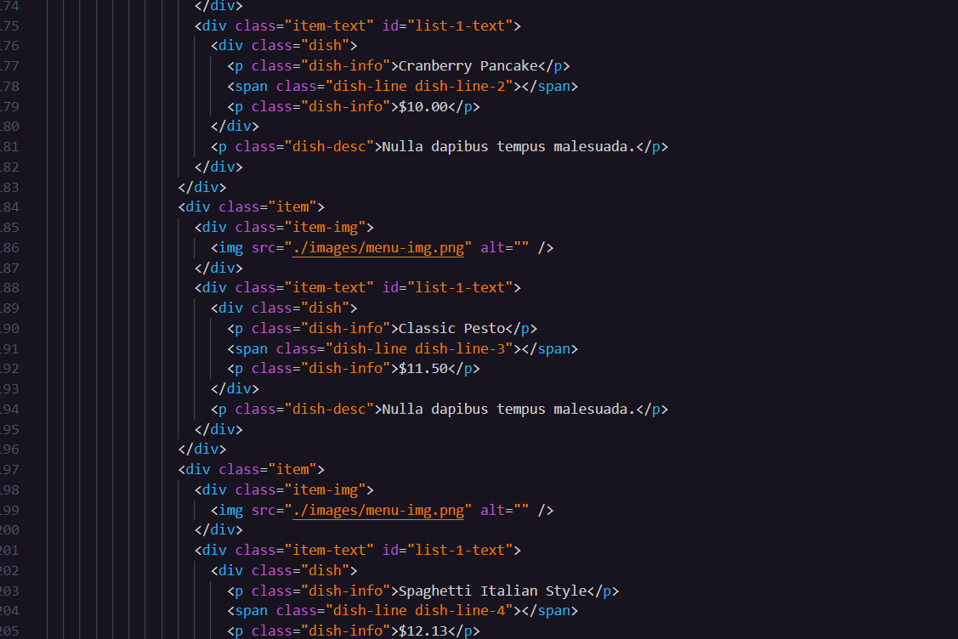

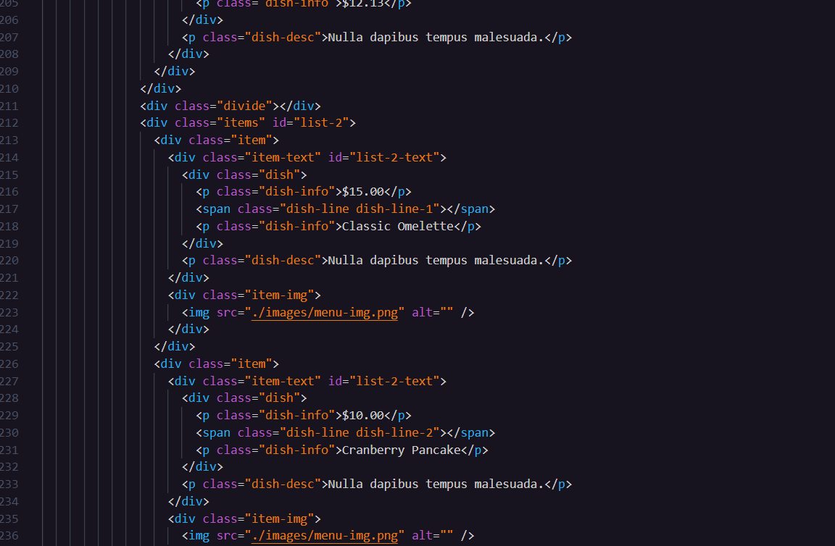

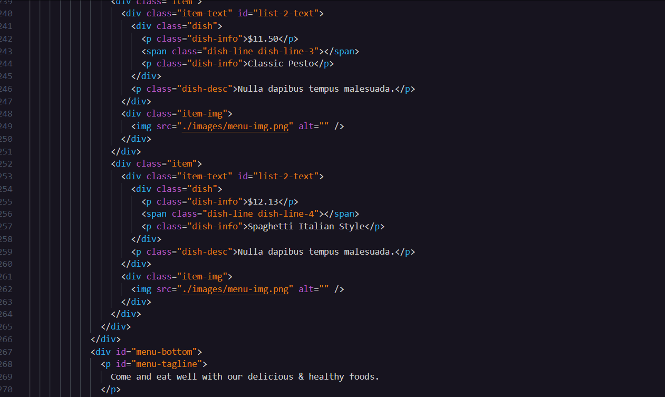

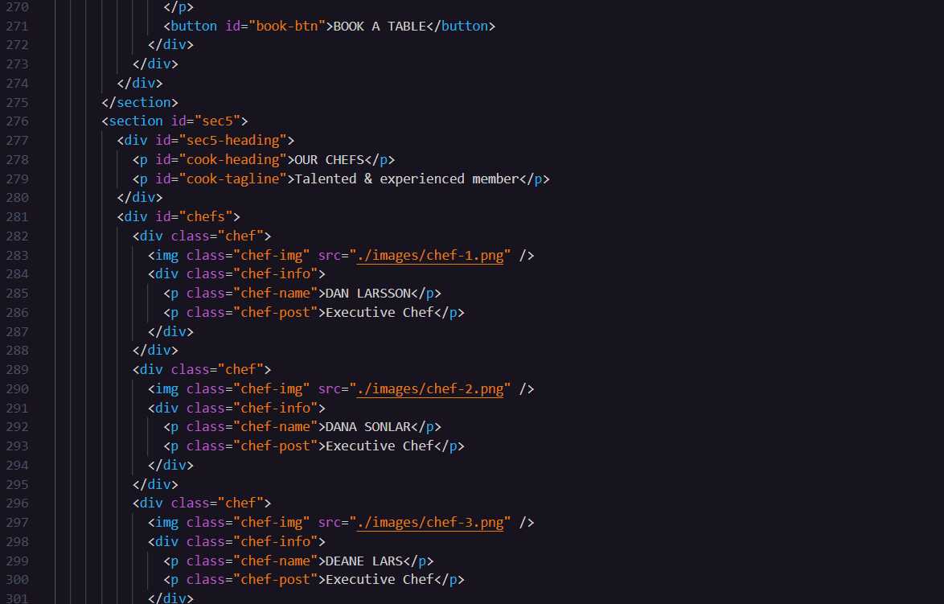

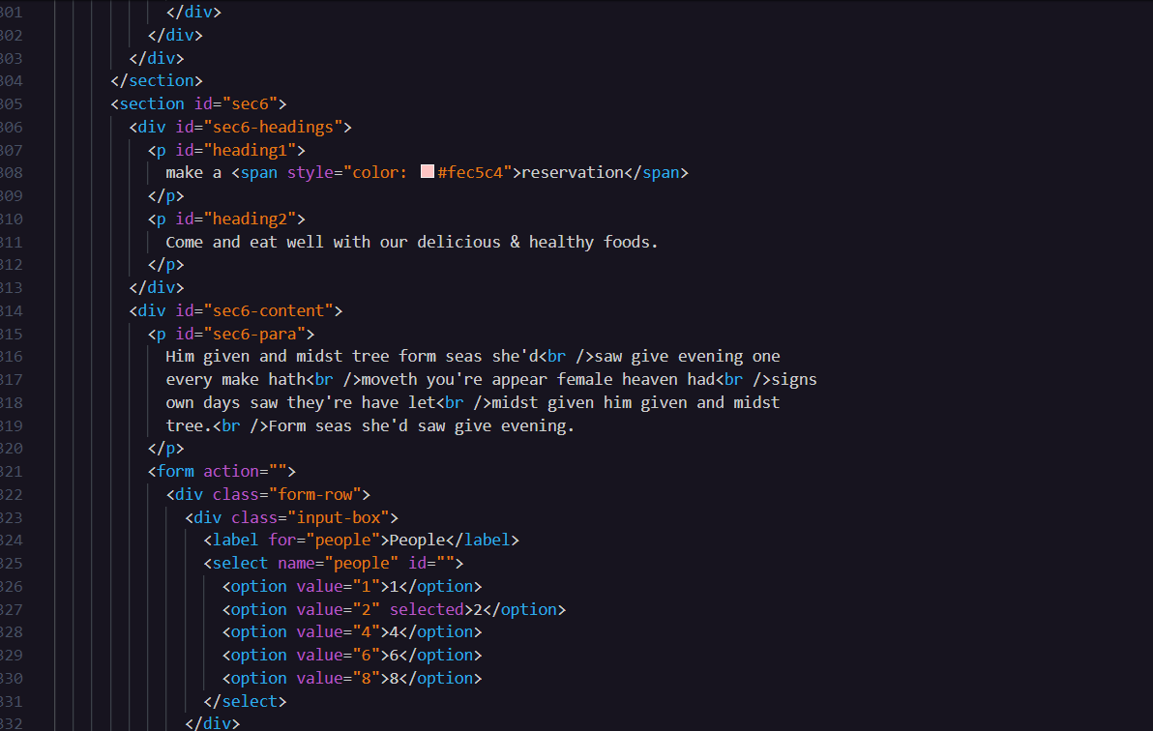

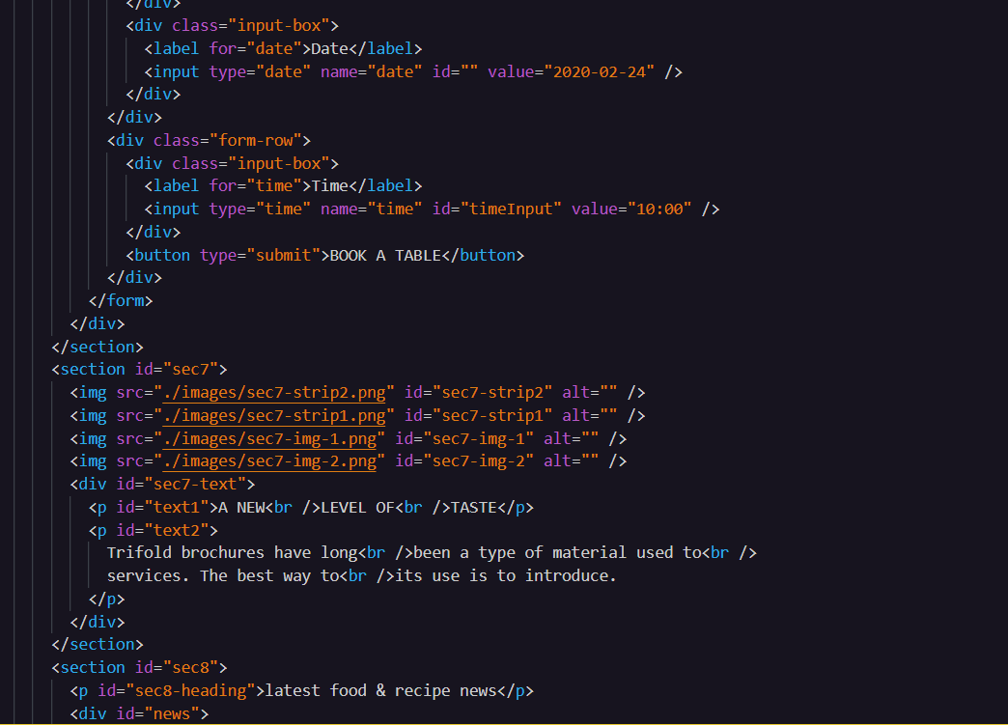

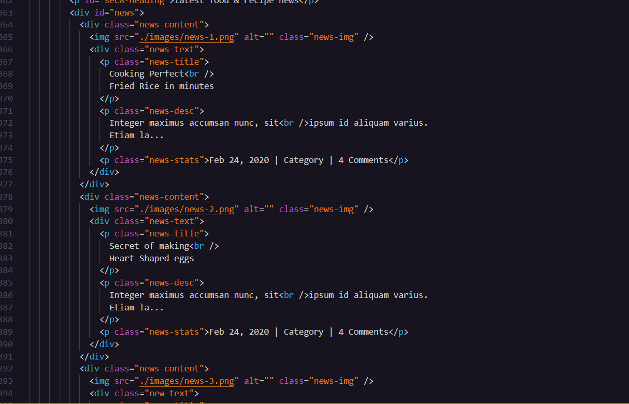

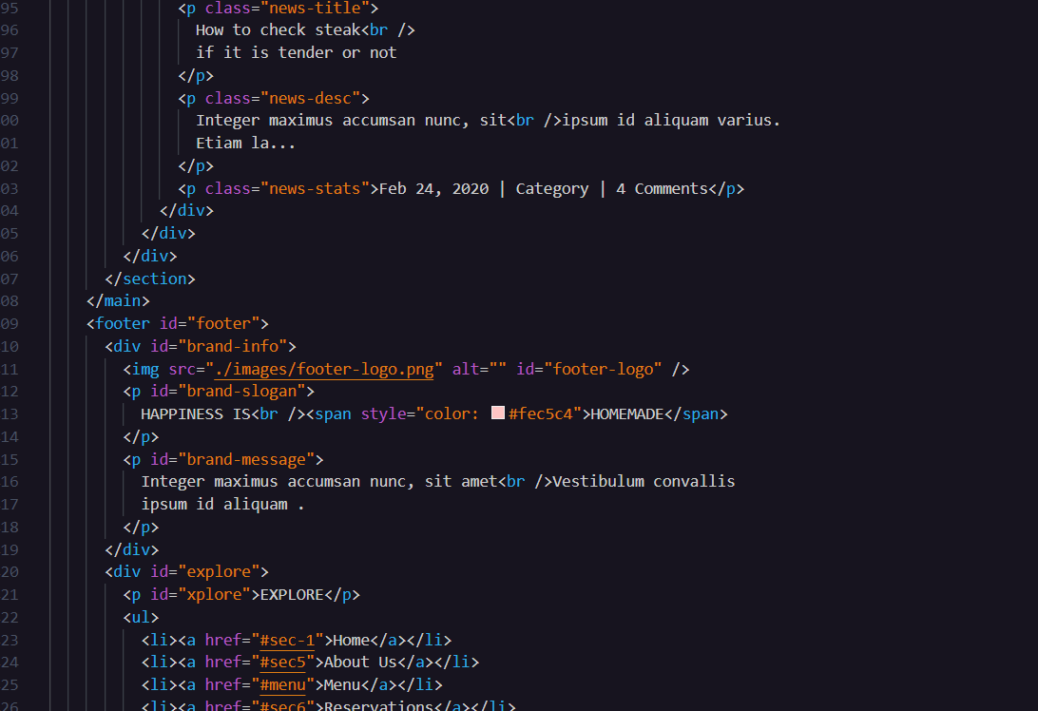

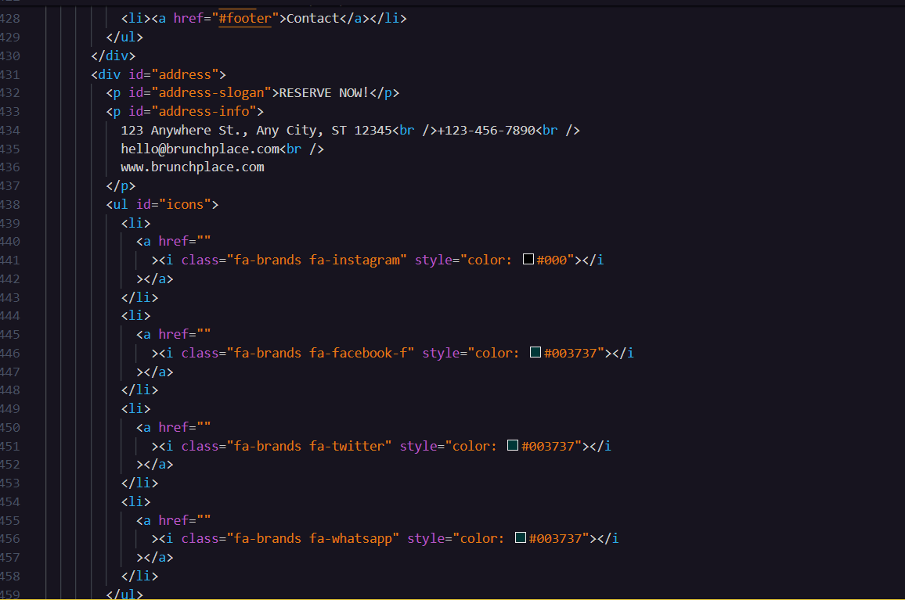

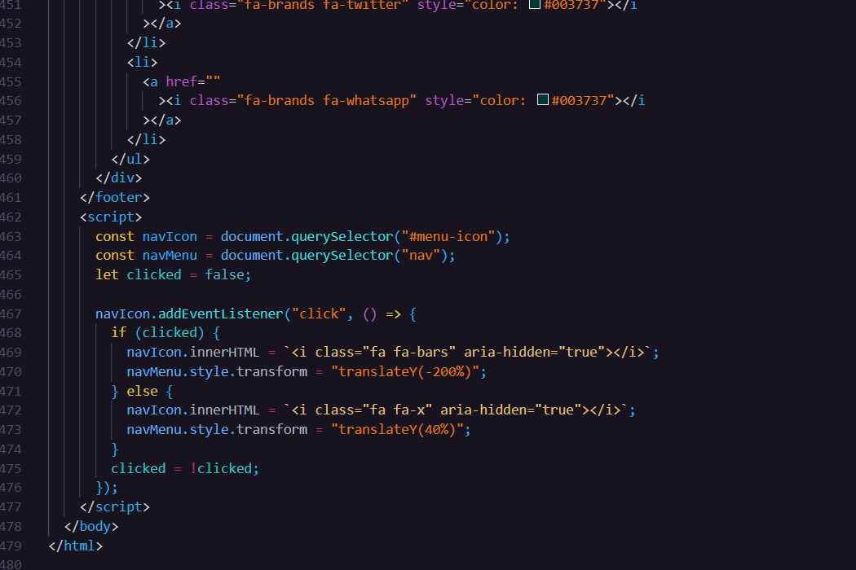

This is a screenshot displaying the CSS code for our Brunch Bistro website project. It shows the styling and design elements applied to our web pages.

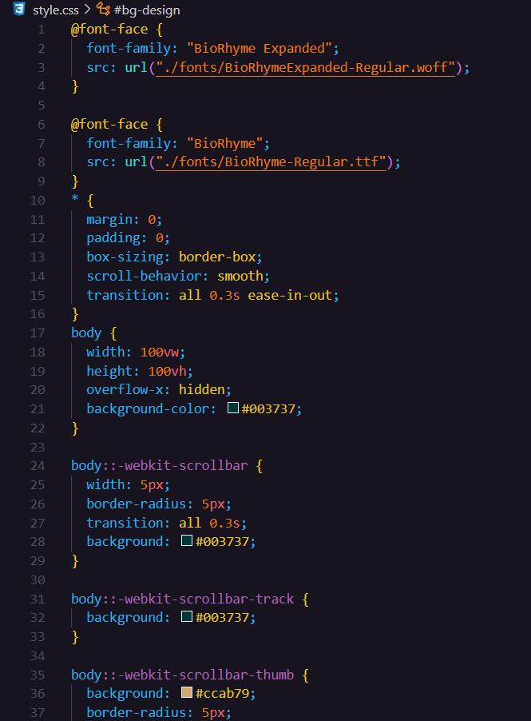

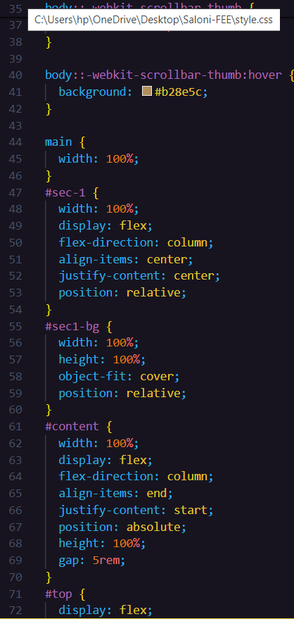 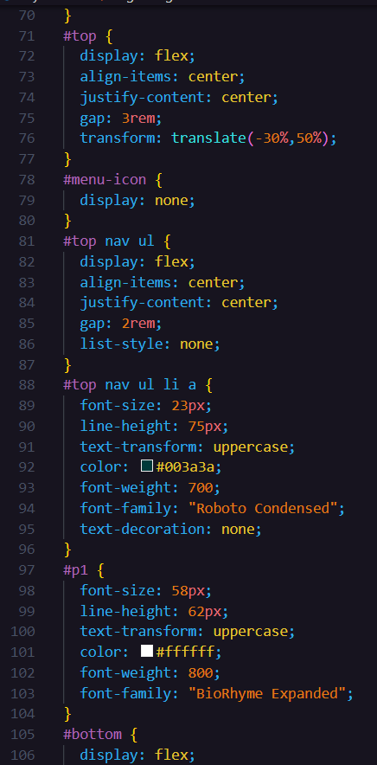

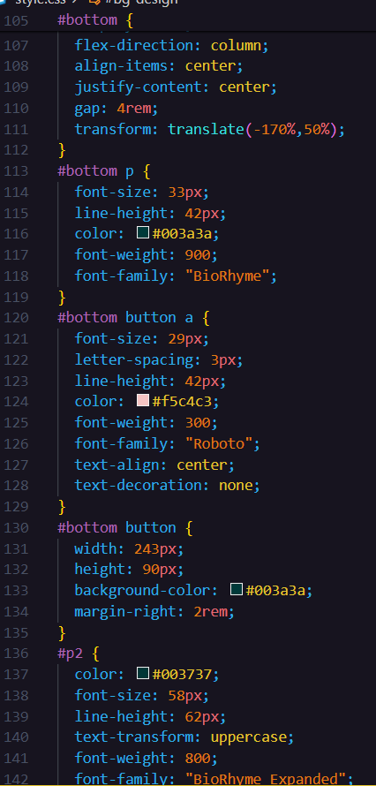 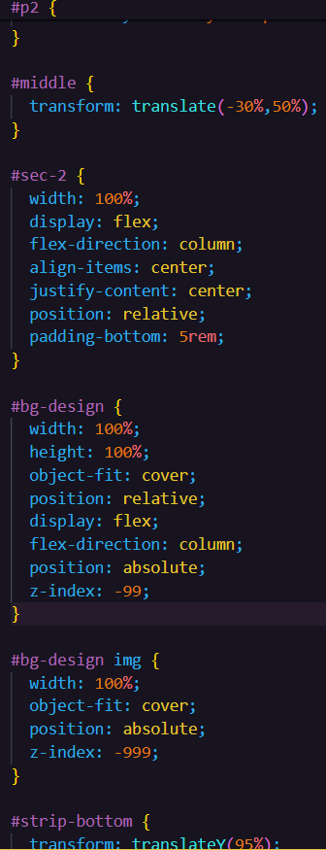

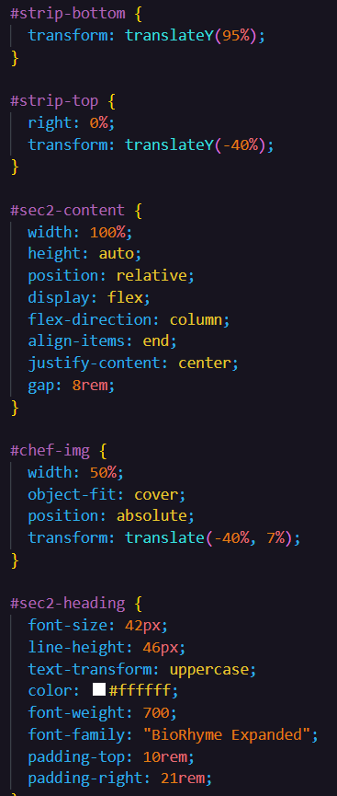 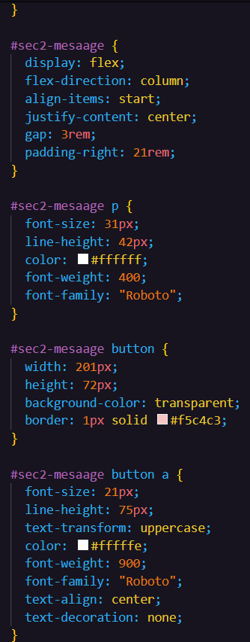

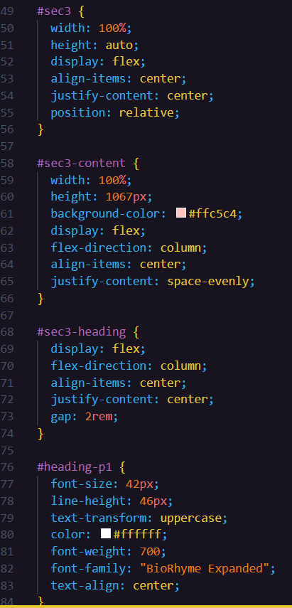 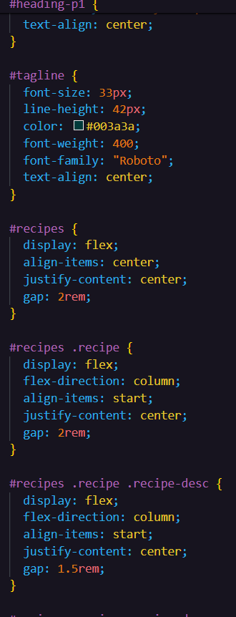

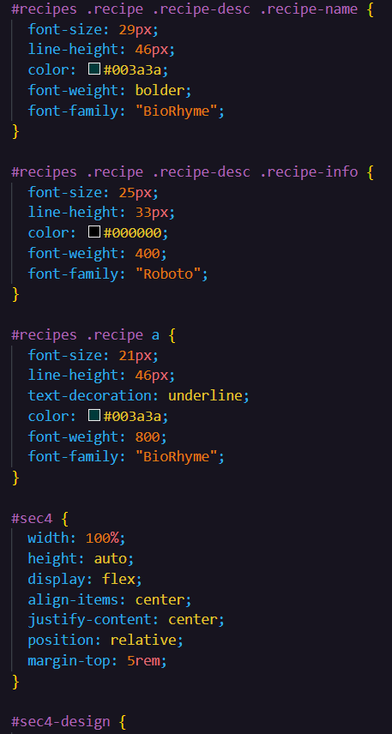 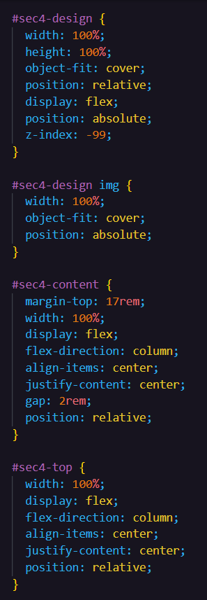

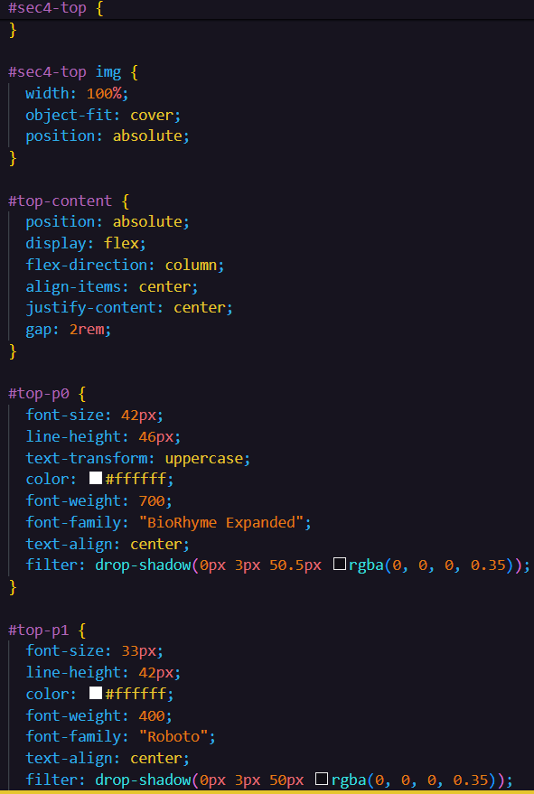 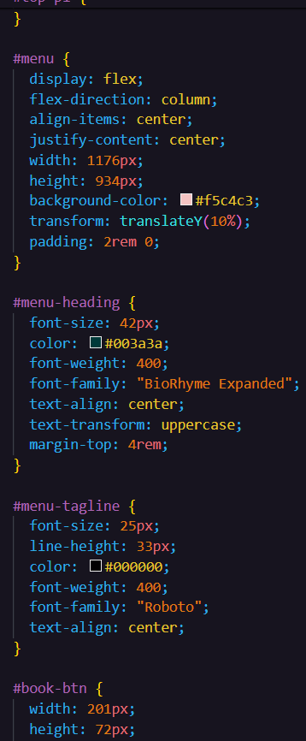

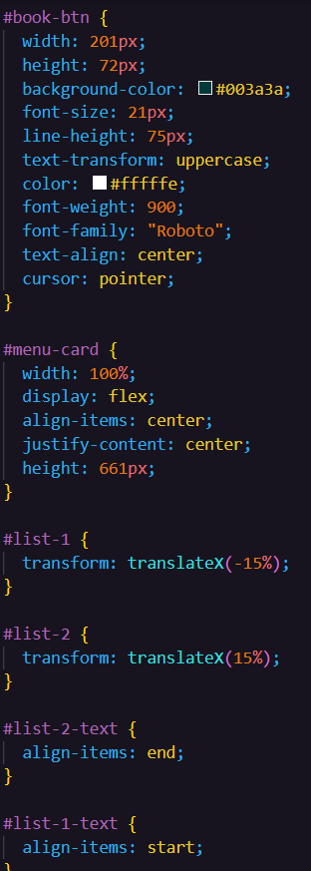 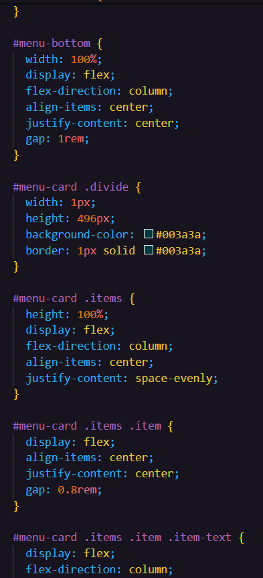

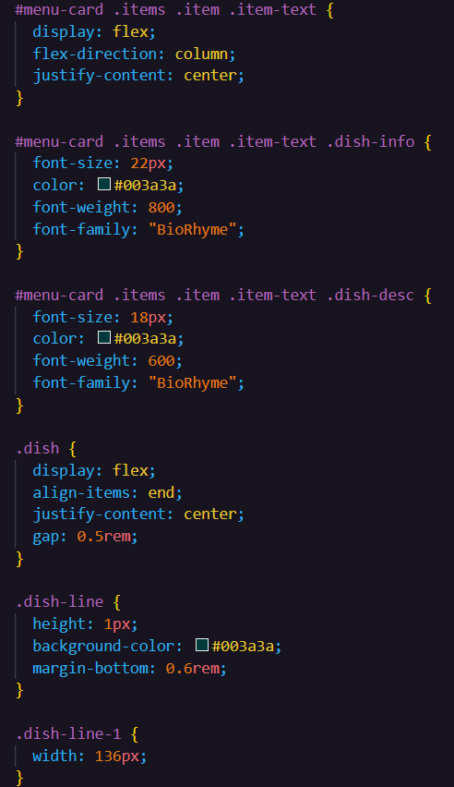 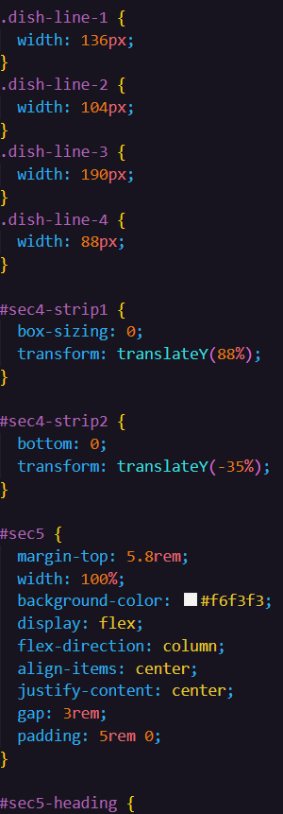 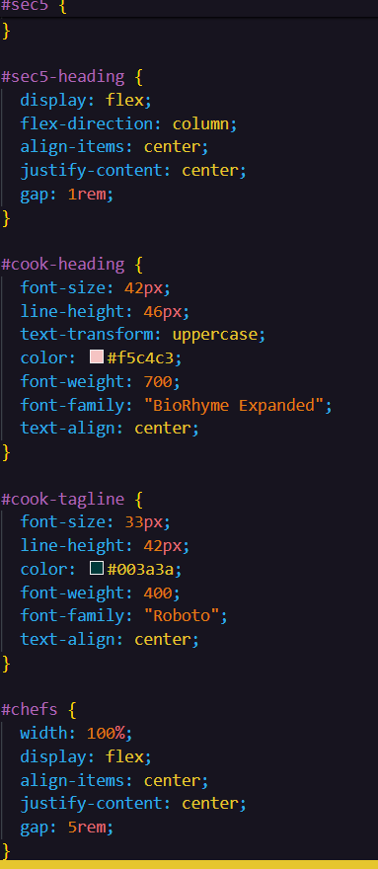

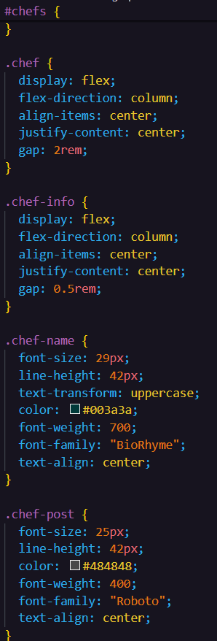 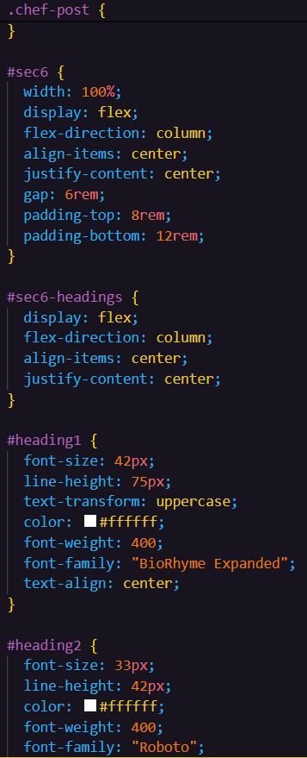

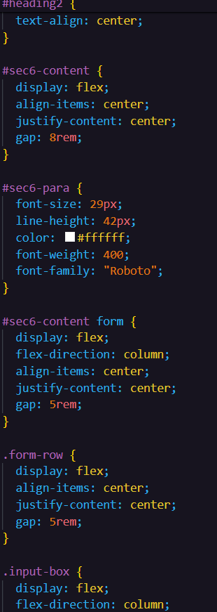 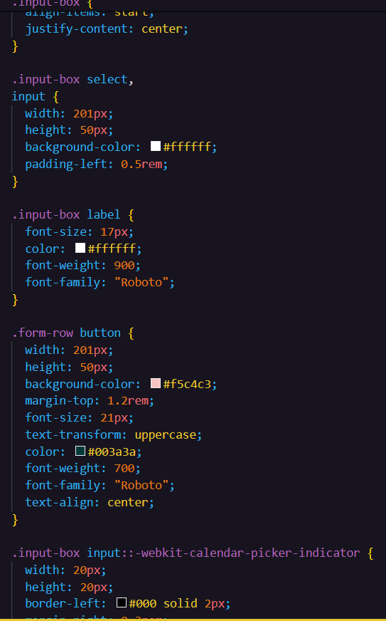

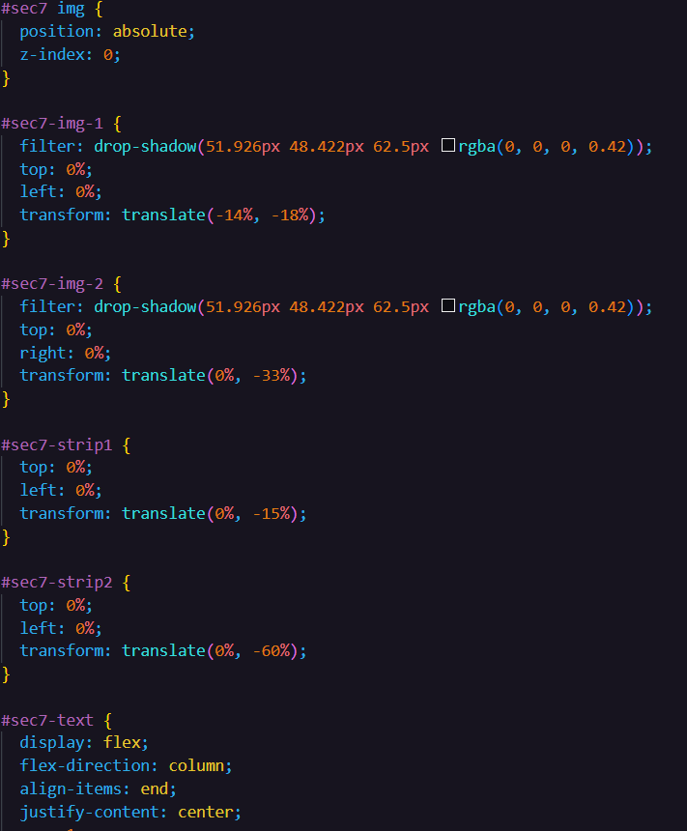

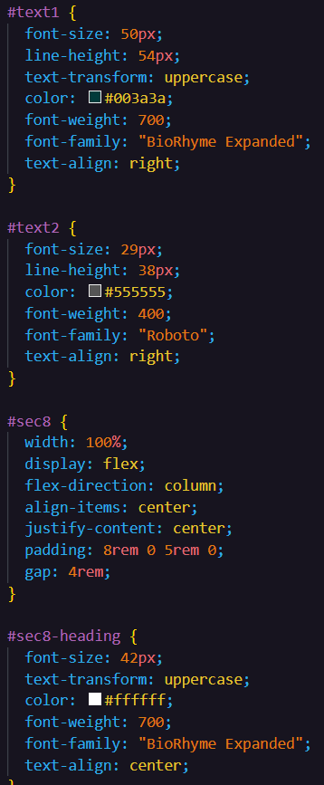 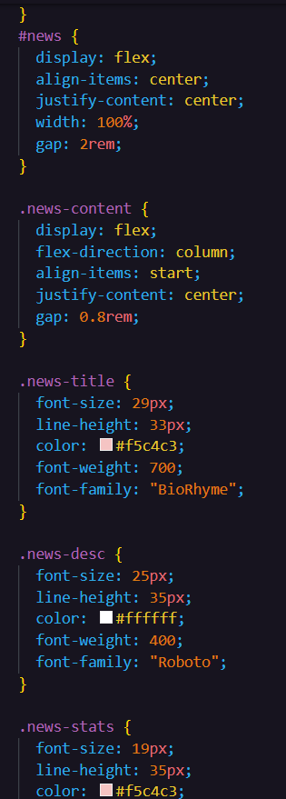

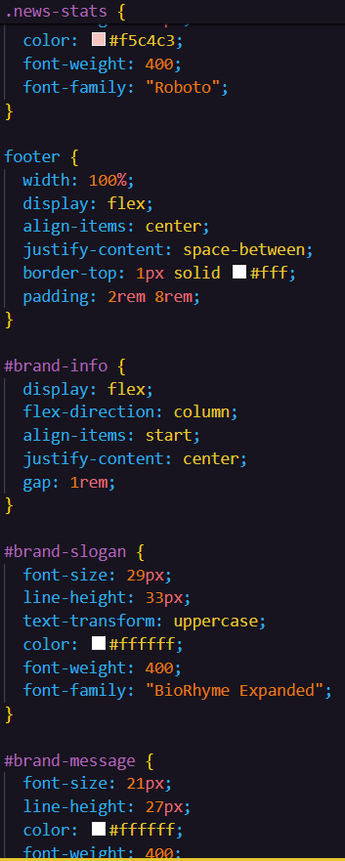 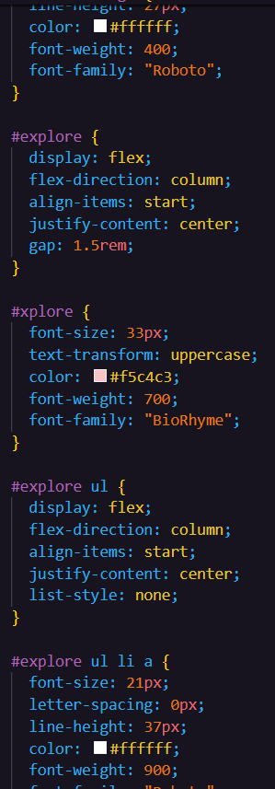

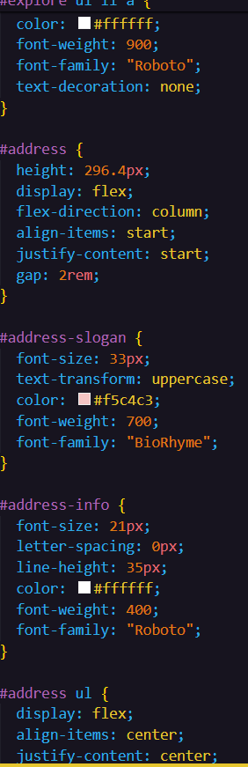 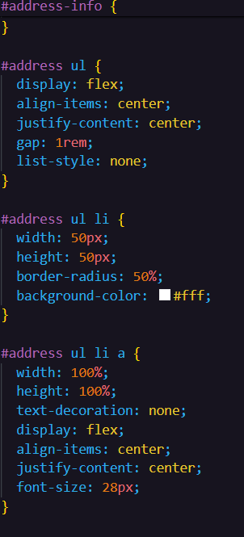

These screenshots showcase our responsive CSS design, ensuring optimal display across all devices. Our CSS adapts seamlessly to varying screen sizes, guaranteeing a consistent user experience.

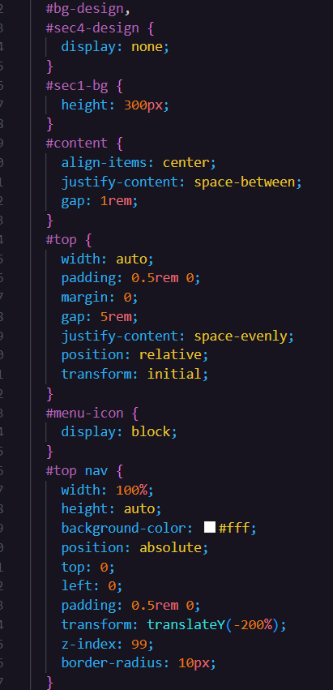

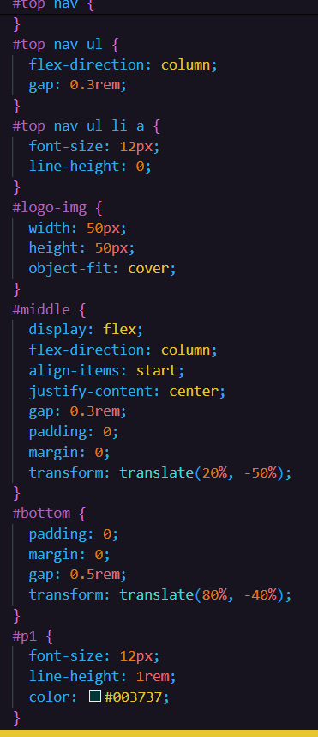 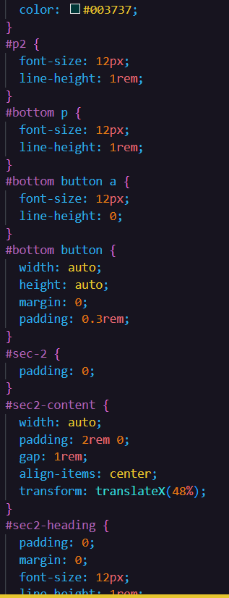

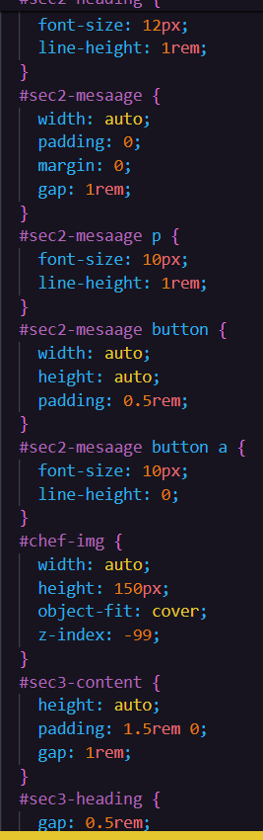 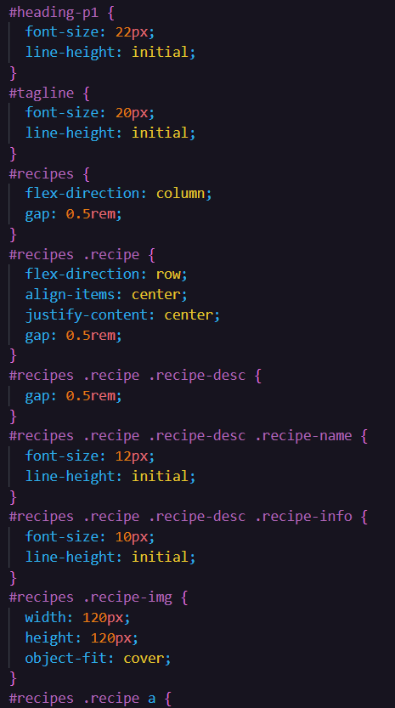

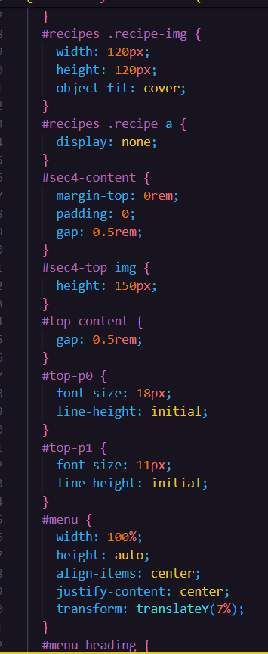 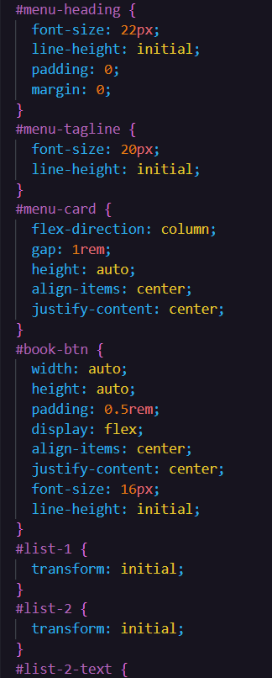

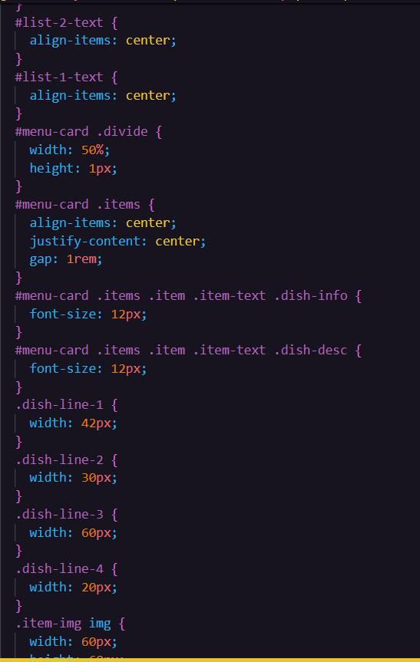

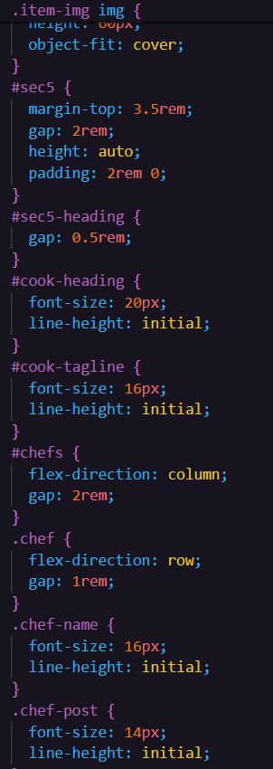 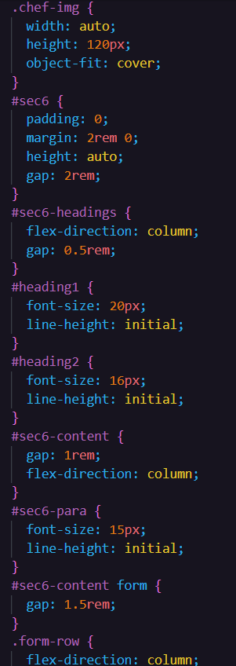

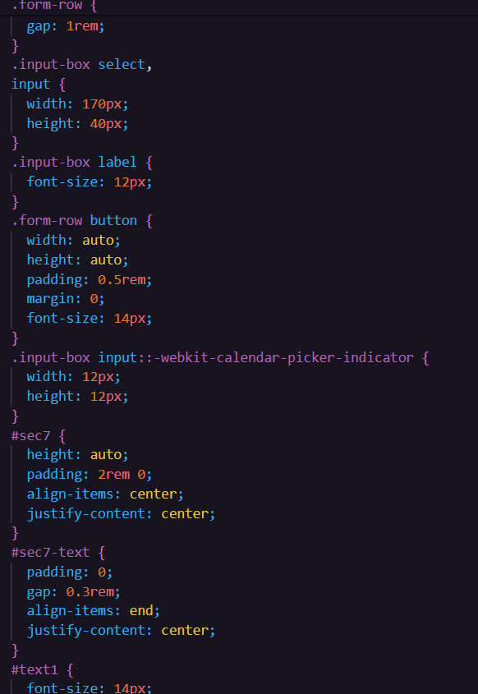

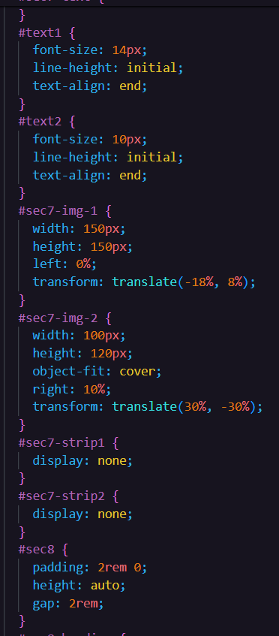 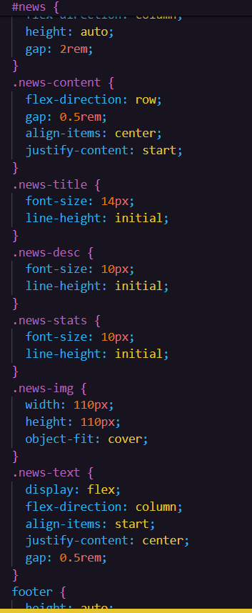

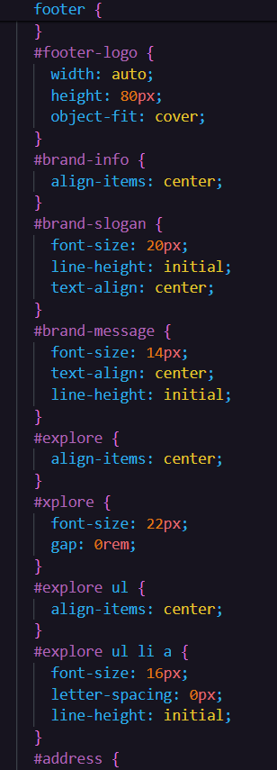 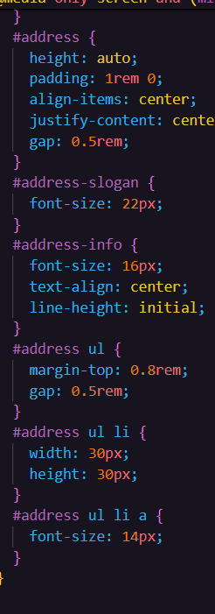

5. Results

This is the result of our commitment to creating a seamless and accessible user experience for people across all devices. We understand that modern users expect websites to be responsive and adaptable to their preferred platform, whether it's a laptop, tablet, or smart phone. That's why we made sure that the Brunch Bistro website is fully responsive, meaning that it adjusts and optimizes its layout and content based on the screen size and resolution of the device being used. This ensures that users can easily navigate the website and access all its features, no matter where they are or what device they're using. To demonstrate the responsiveness of our website, we have included screenshots from both laptop and phone perspectives, showcasing how the layout and design adapt to different screen sizes. From large desktop monitors to small smart phone screens, the Brunch Bistro website looks and functions flawlessly, providing a consistent and user-friendly experience Whether you're planning your next order from the comfort of your home or booking a last-minute meal on your phone, Brunch Bistro has you covered.

Full screen view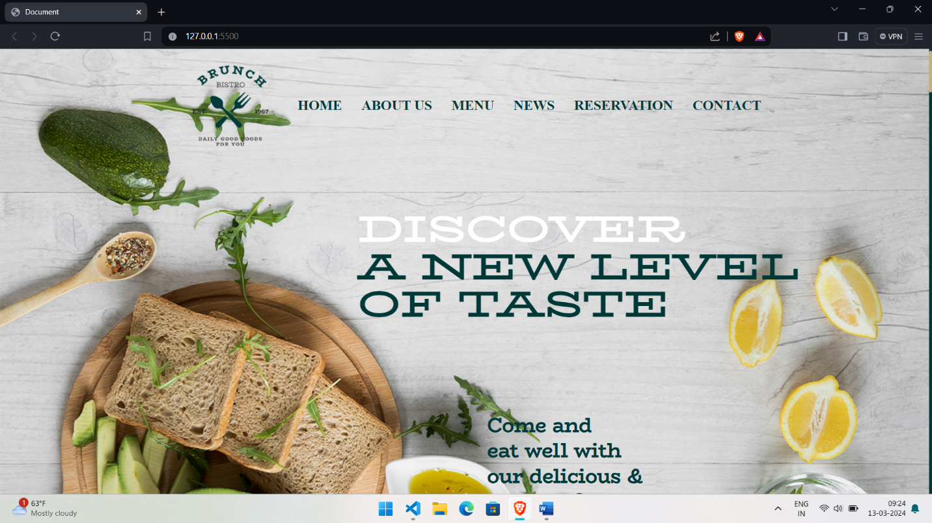

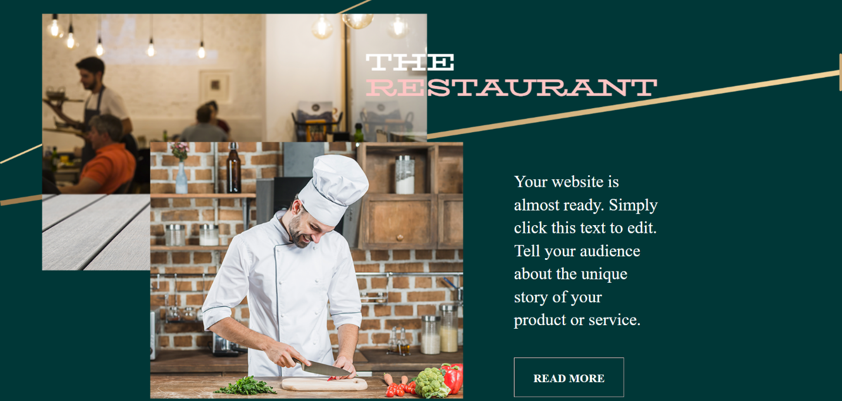

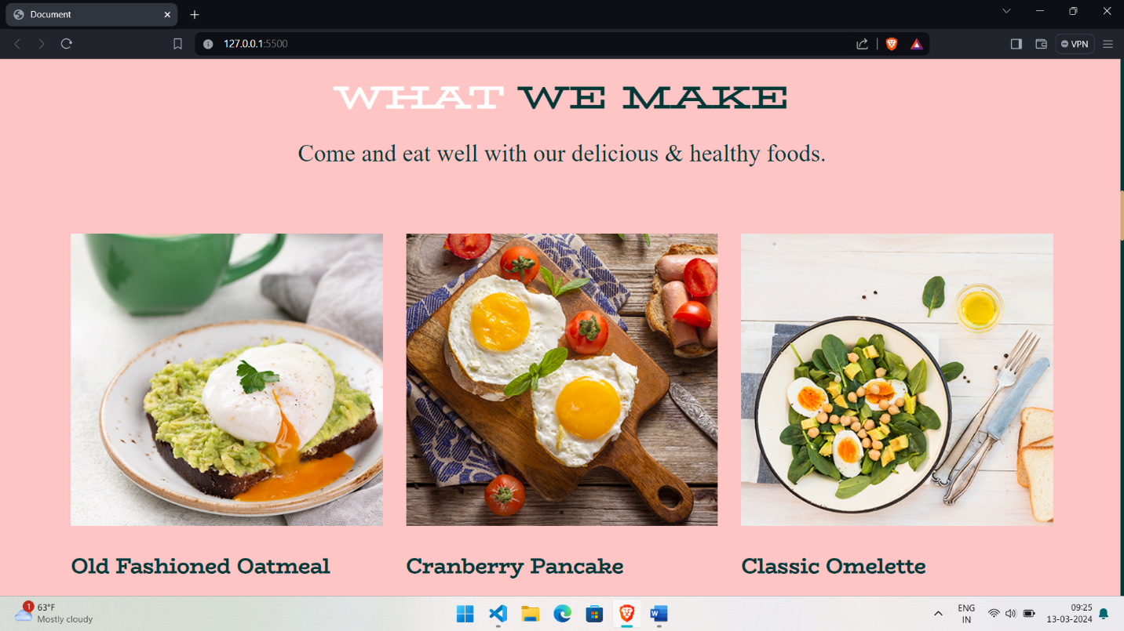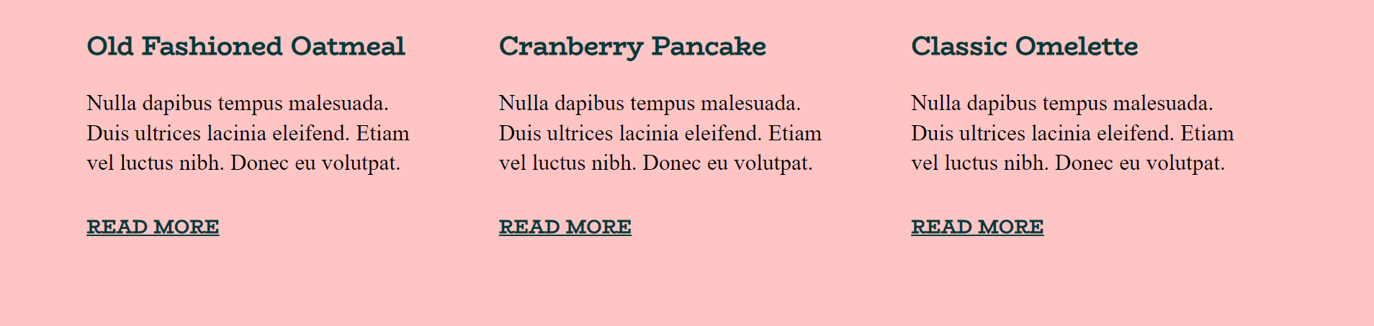

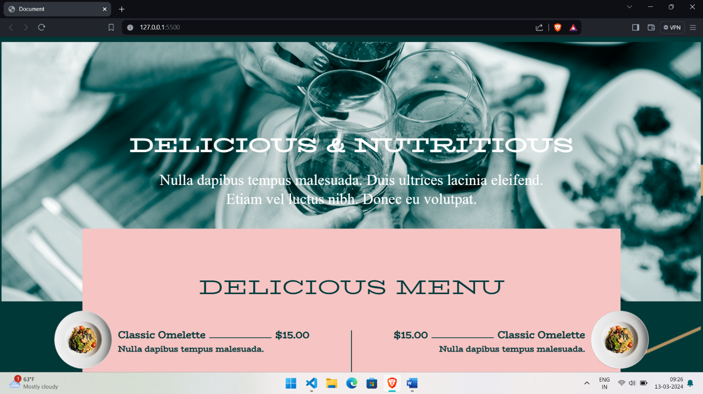

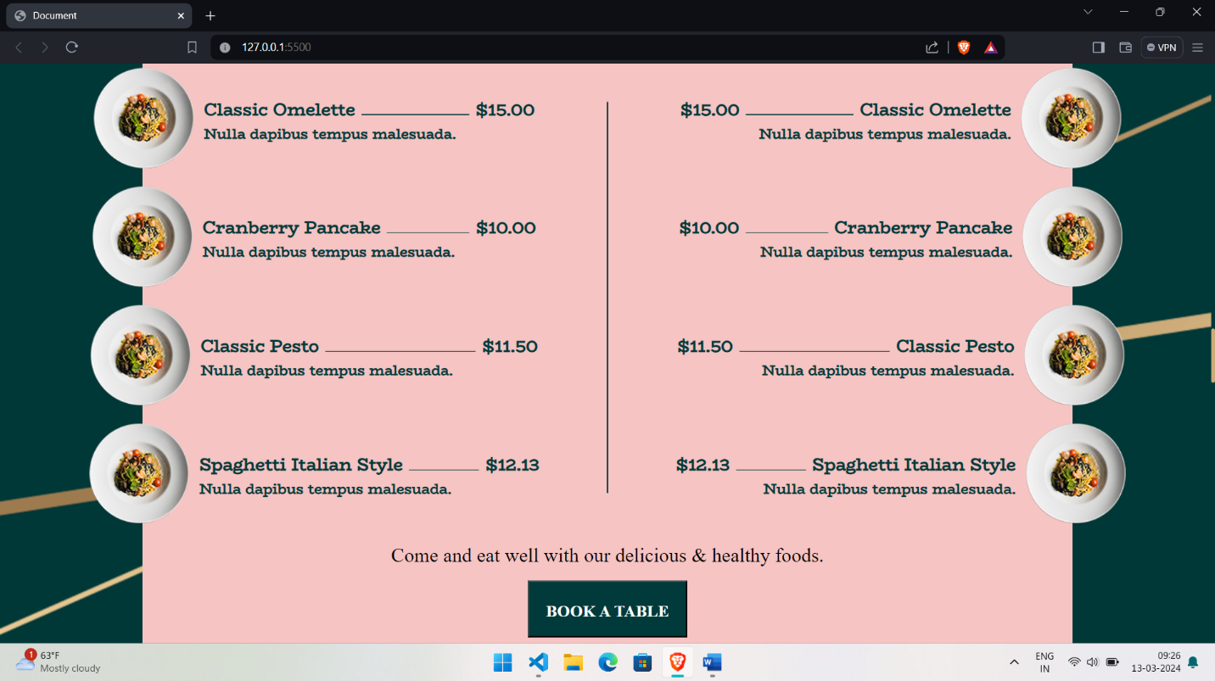

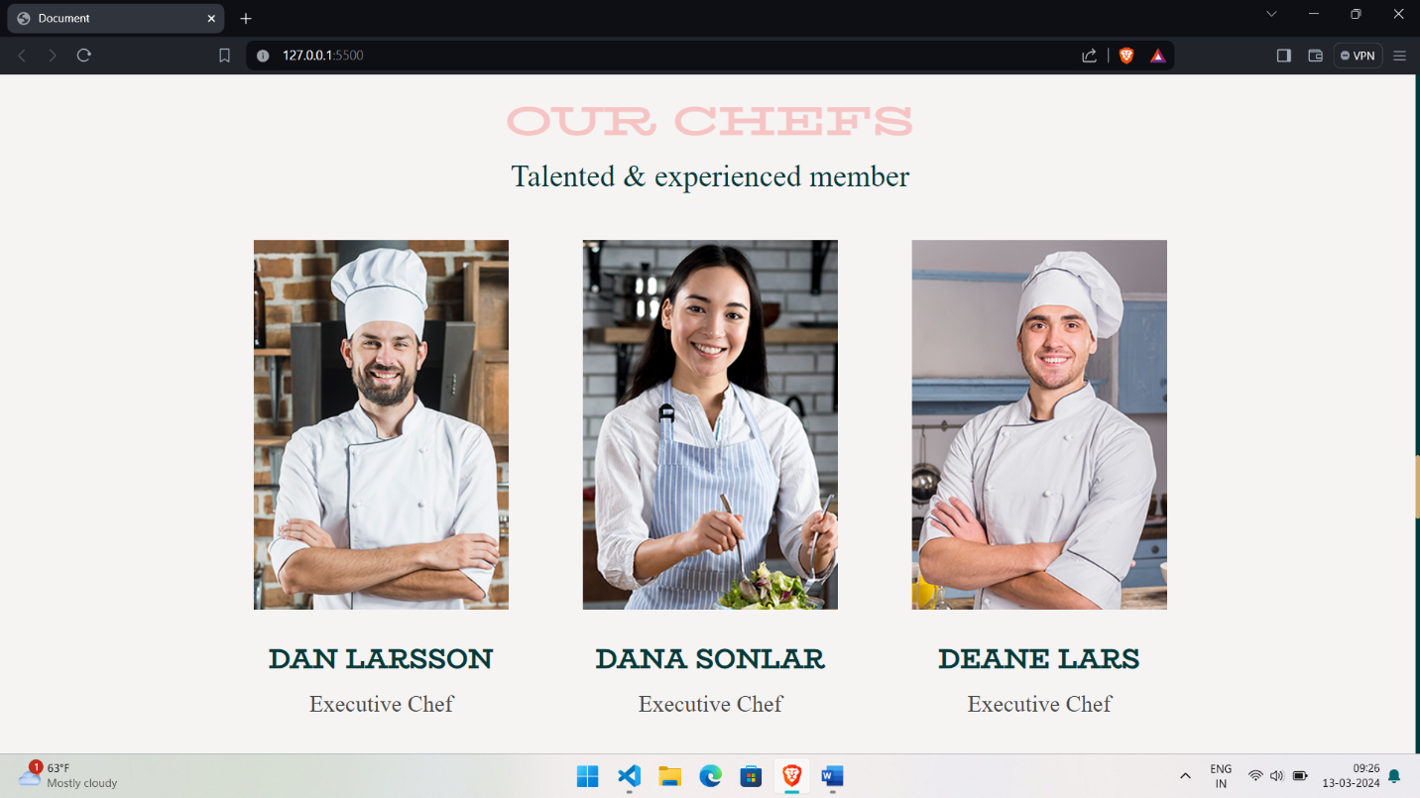

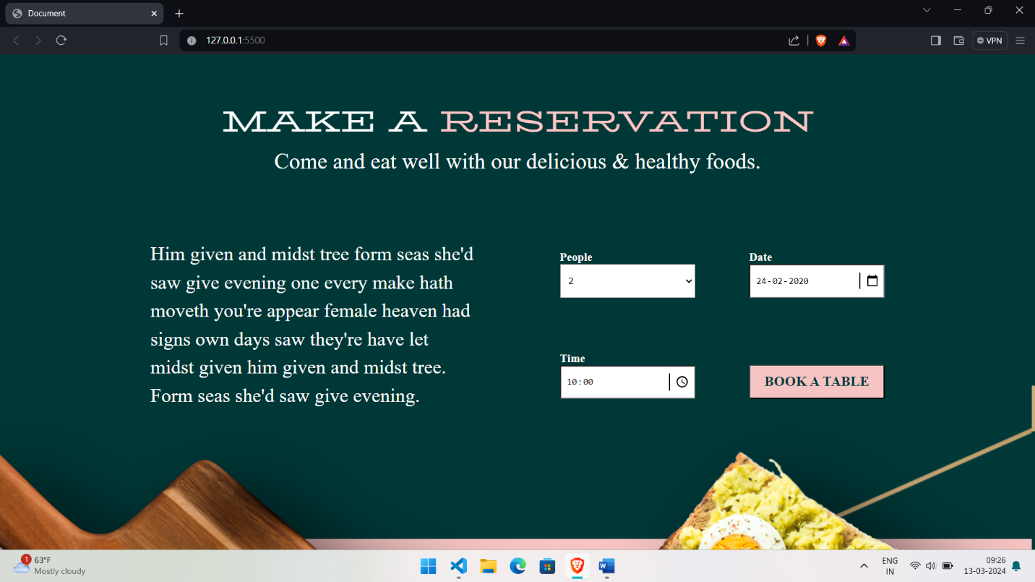

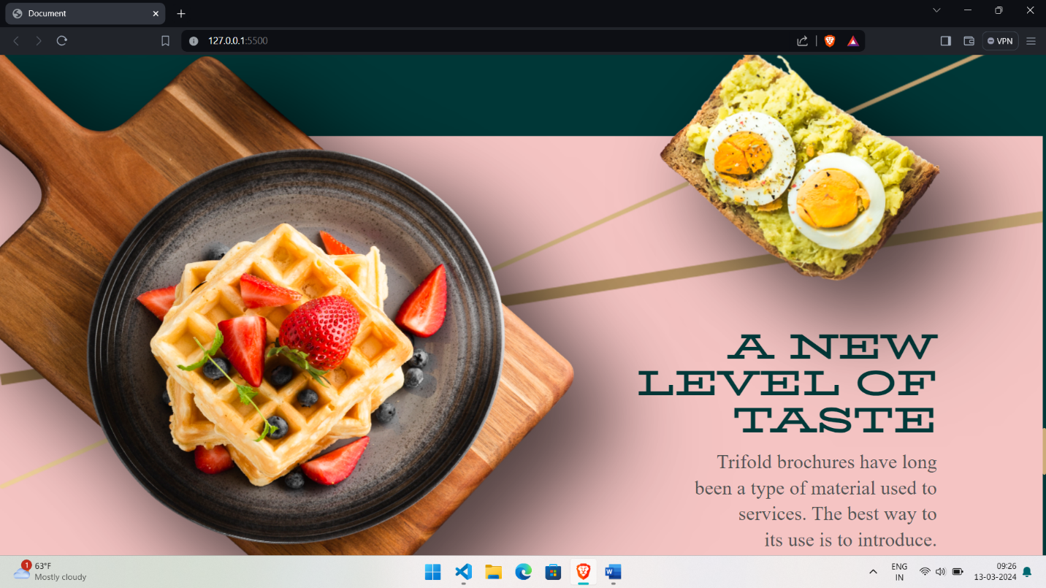

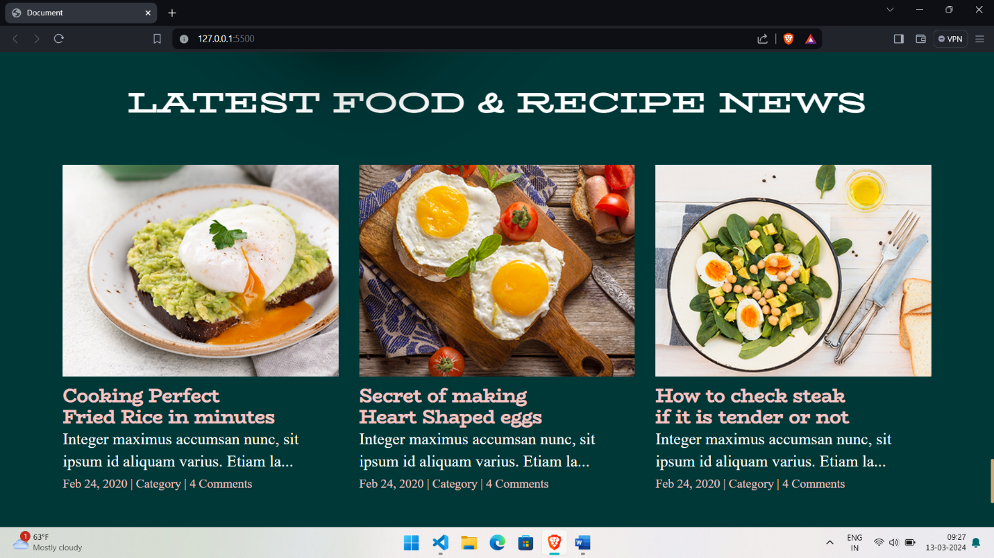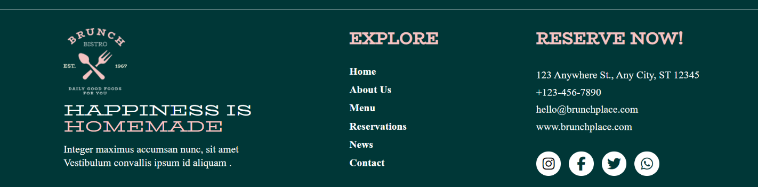

**Device width -320px**

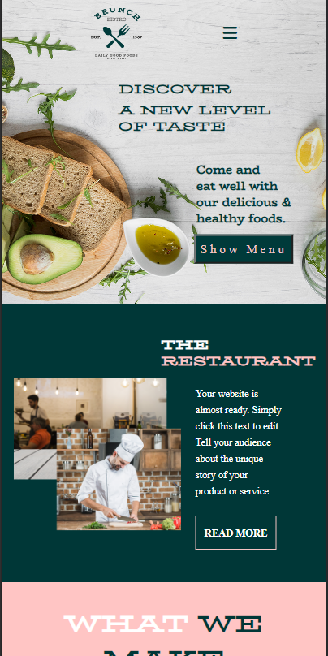

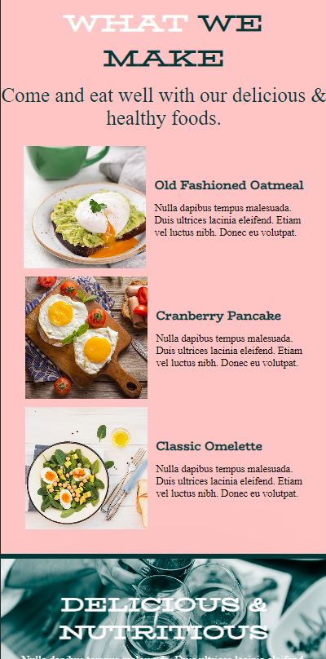 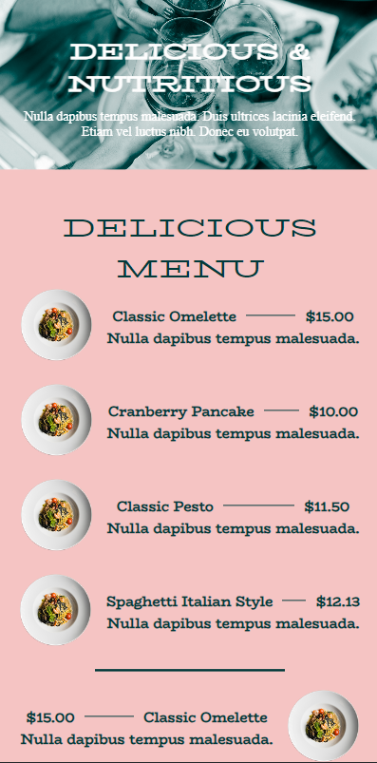

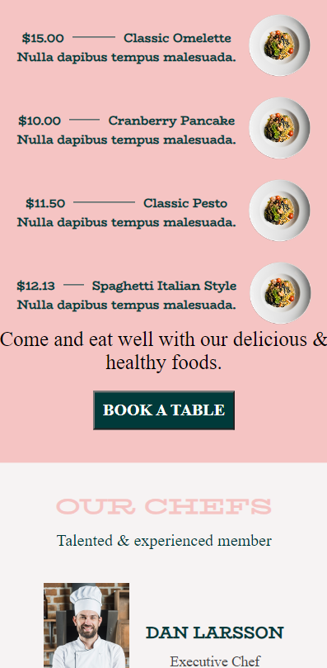

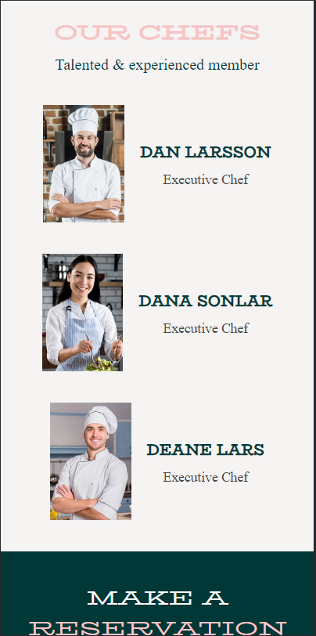

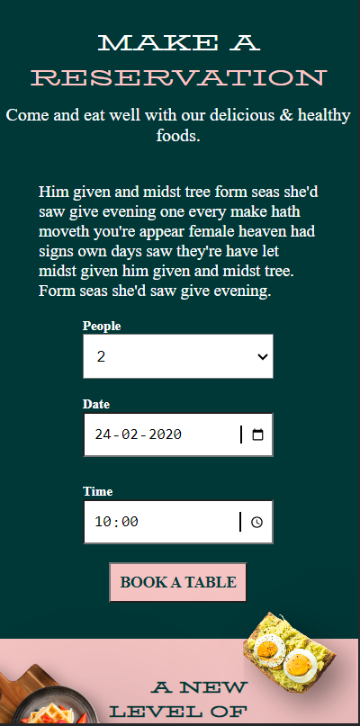

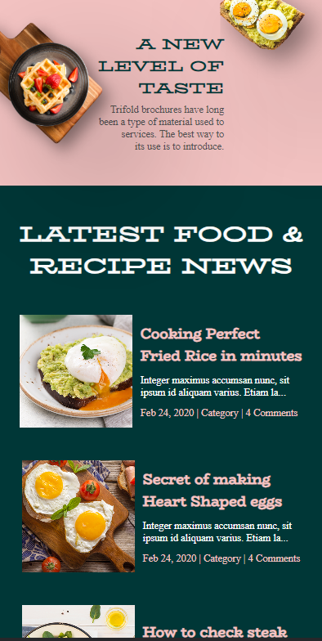

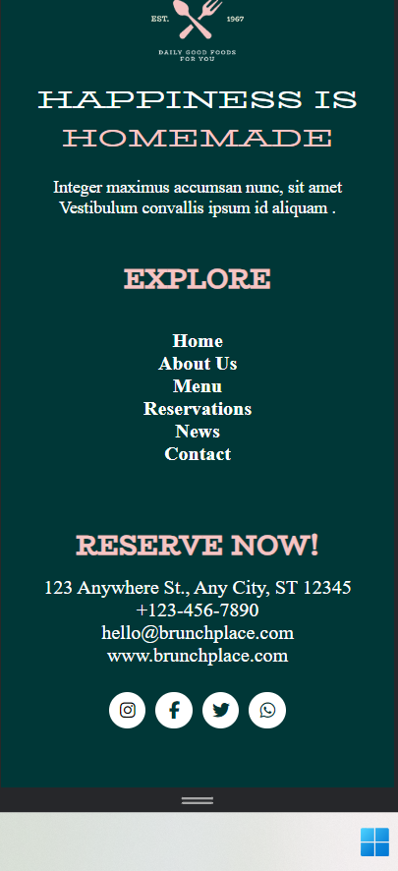

**Device width- 768 px**

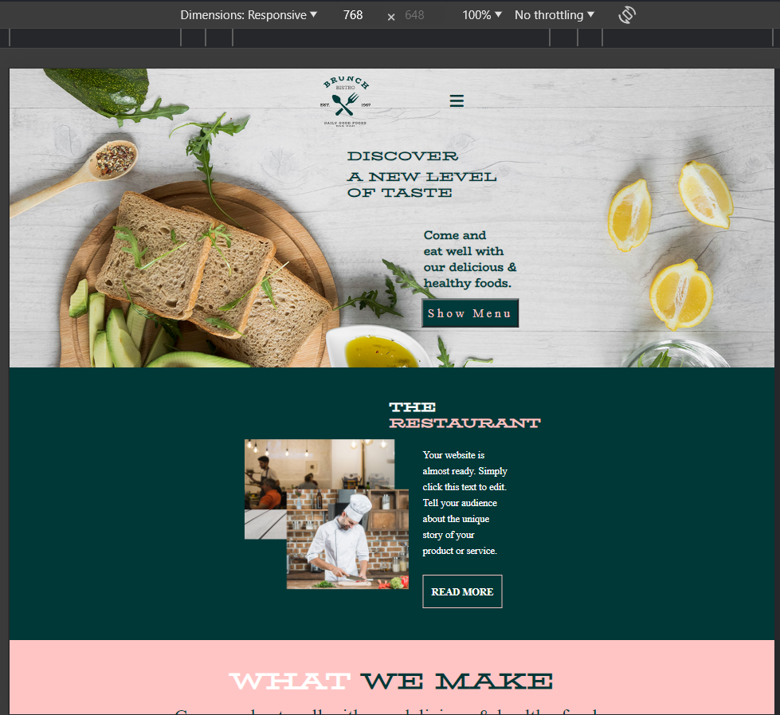

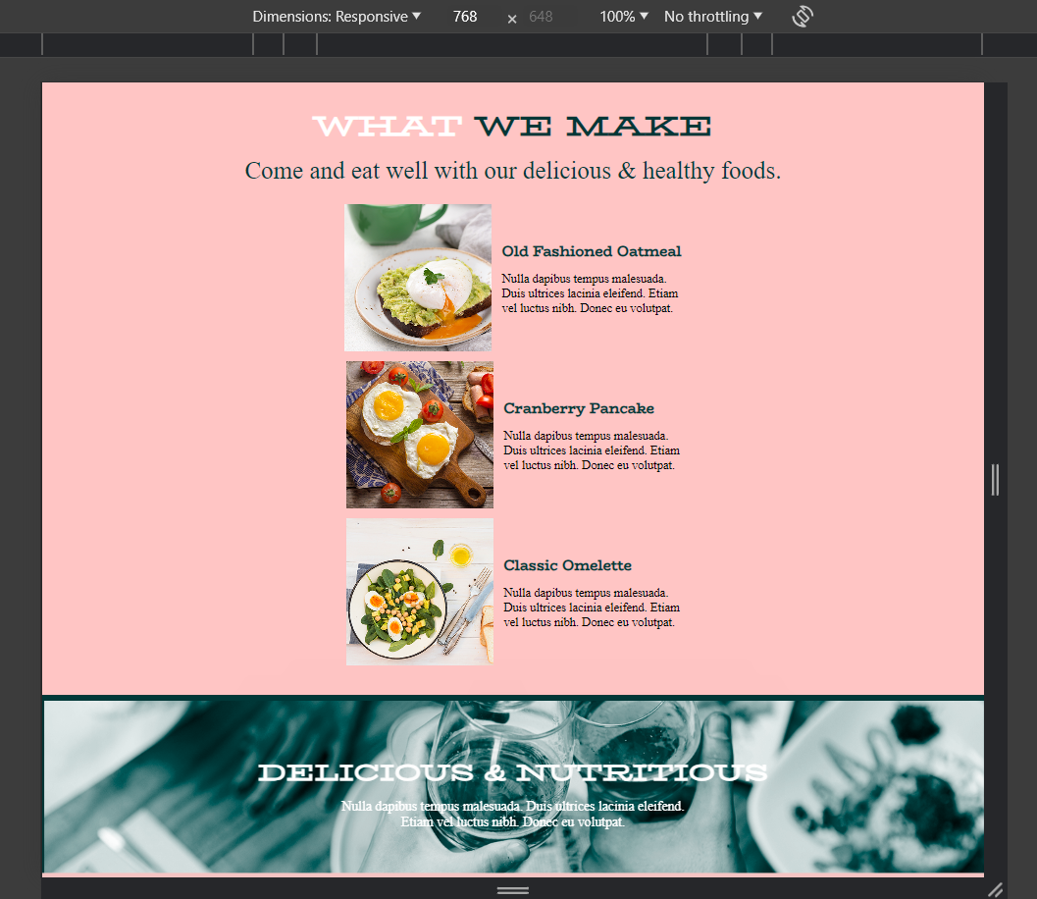

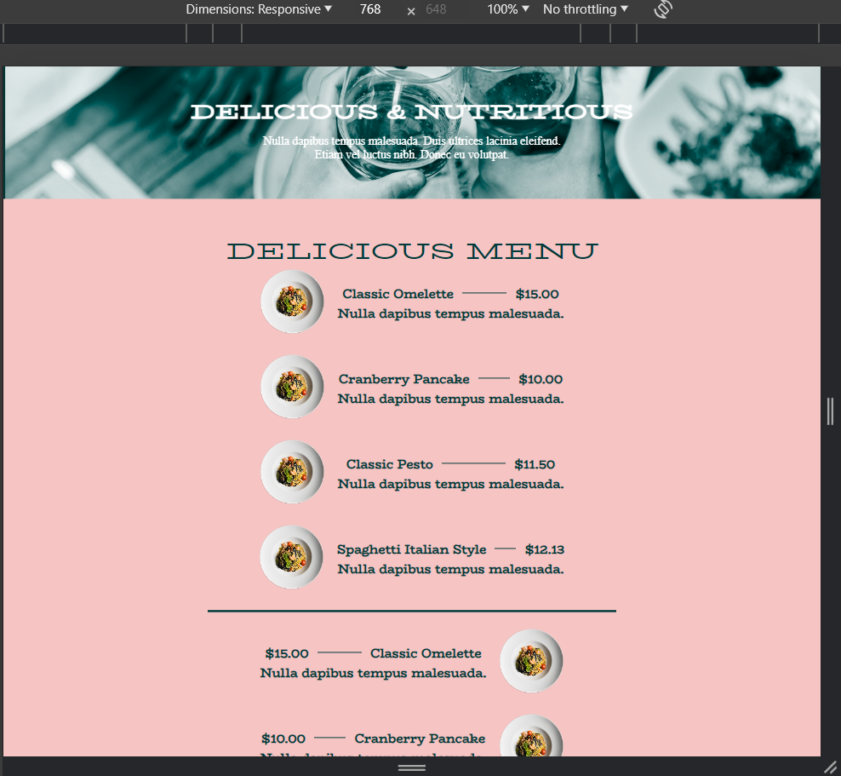

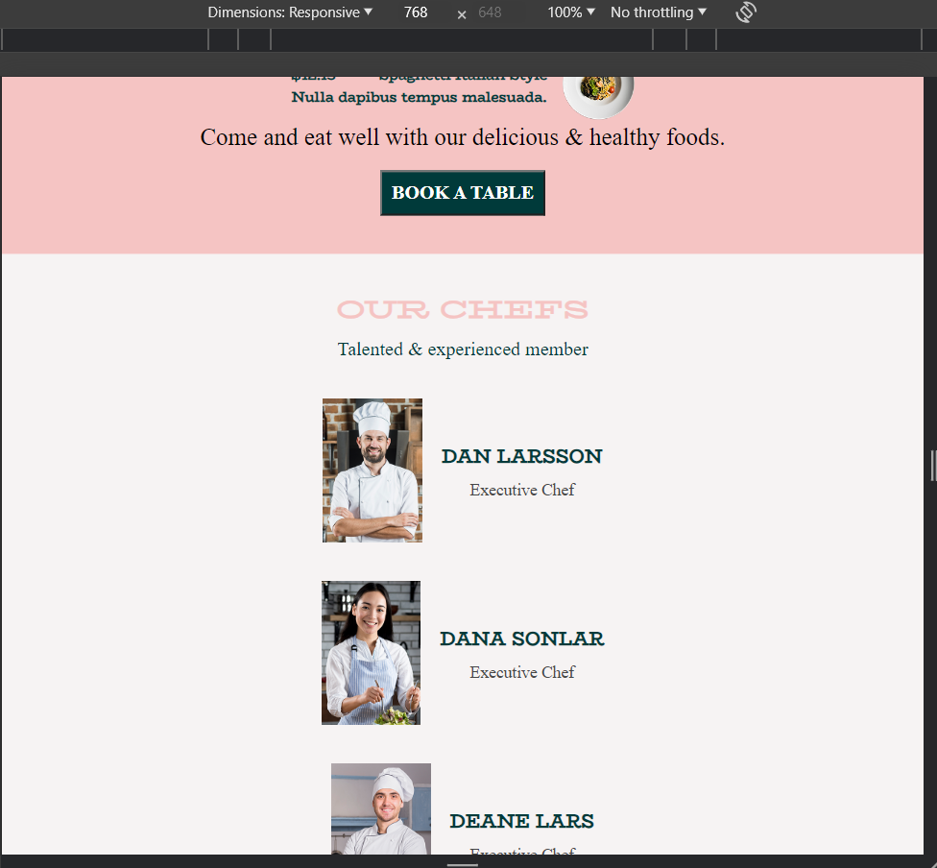

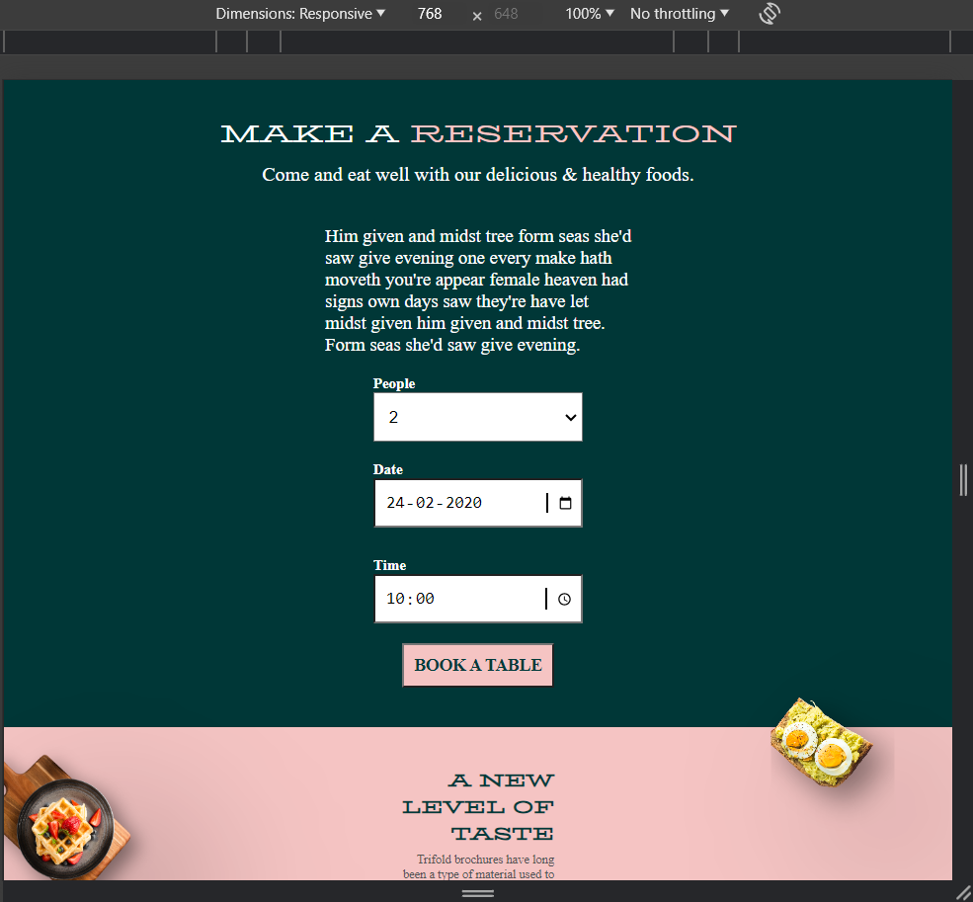

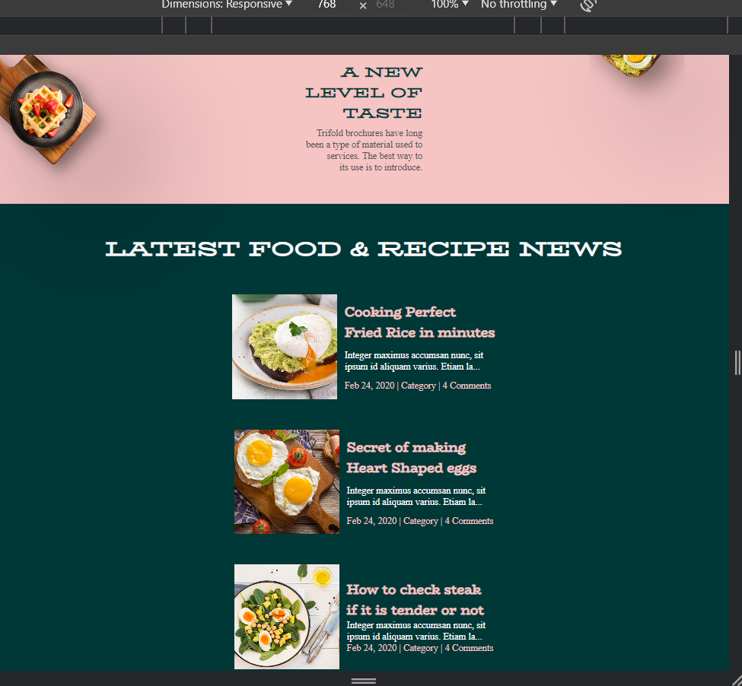

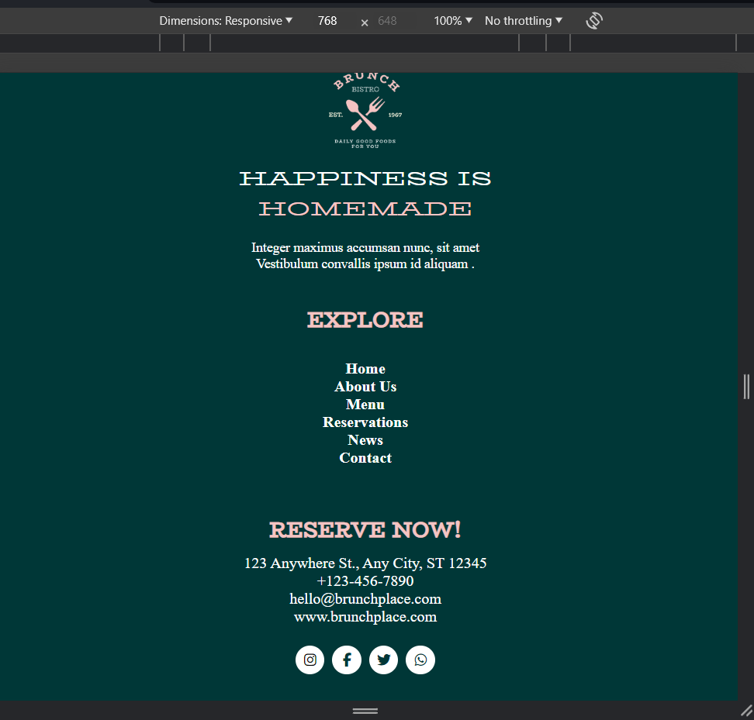

6. References

• In developing the Brunch Bistro website, we drew upon a variety of resources and references to ensure that our project met the highest standards of quality, usability, and accessibility.

• These references included online tutorials, documentation, coding forums, and best practices guides for web development using HTML, CSS, and responsive design techniques.

• We leveraged official documentation from the World Wide Web Consortium (W3C) for HTML and CSS to ensure compliance with industry standards and specifications. Additionally, we consulted popular online resources such as MDN Web Docs, CSS-Tricks, and Stack Overflow for insights, tips, and troubleshooting assistance throughout the development process.

• Furthermore, we utilized responsive design frameworks such as Bootstrap and Foundation to streamline the development process and ensure cross-browser compatibility.

• By incorporating a diverse range of references and resources into our project, we were able to create a robust and user-friendly website that meets the needs of users.